SMART MULTI-FLOOR PARKING MANAGEMENT SYSTEM USING IOT

An Industrial Oriented Mini Project report submitted in partial fulfillment for the award of the Degree

of

BACHELOR OF TECHNOLOGY
in
Electronics & Communication Engineering
by
NAME OF THE CANDIDATES
D.VENKAT RAMANA REDDY (Regd.No.21891A0480)
P. RAGHAVENDRA REDDY (Regd.No.21891A04A4)
T. NANDA KUMAR (Regd.No.21891A04B5)
N. KARTHIK (Regd.No.22895A0402)
Under the guidance of
Dr. P. A. HARSHA VARDHINI
Head of the Department

DEPARTMENT OF
ELECTRONICS & COMMUNICATION ENGINEERING



2024-25

CERTIFICATE

This is to certify that the project report entitled “SMART MULTI-FLOOR PARKING MANAGEMENT SYSTEM USING IOT” submitted by D. Venkat Ramana Reddy(21891A0480),P. Raghavendra Reddy(21891A04A4), T. Nanda Kumar (21891A04B5), N. Karthik (22895A0402) to the Vignan Institute of Technology & Science, Yadadri, Bhuvanagiri Dist., in partial fulfillment for the award of the degree of
Bachelor Of Technology in Electronics & Communication Engineering is a bonafide record of project work carried out by them under my supervision. The contents of this report, in full or in parts, have not been submitted to any other Institution or University for the award of any degree or diploma.

Dr. P. A. Harsha Vardhini Dr. P. A. Harsha Vardhini

Professor & HOD Head of The Department

(External Examiner)

DECLARATION
We declare that this project report titled SMART MULTI-FLOOR PARKING MANAGEMENT SYSTEM USING IOT submitted in partial fulfillment of the degree of B. Tech in Electronics & Communication Engineering is a record of original work carried out by us under the supervision of Dr. P. A. HARSHA VARDHINI and has not formed the basis for the award of any other degree or diploma, in this or any other Institution or University. In keeping with the ethical practice in reporting scientific information, due acknowledgements have been made wherever the findings of others have been cited.

D.VENKAT RAMANA REDDY 21891A0480
P. RAGHAVENDRA REDDY 21891A04A4
T. NANDA KUMAR 21891A04B5
N. KARTHIK 22895A0402

Date : Hyderabad.

ACKNOWLEDGEMENT
Every project big or small is successful largely due to the effort of a number of wonderful people who have always given their valuable advice or lent a helping hand. We sincerely appreciate the inspiration; support and guidance of all those people who have been instrument as in making this project success.
We thank our beloved Chairman, Dr. L Rathaiah, who gave us great encouragement to work.
We thank CEO, Mr. Boyapati Shravan, we remember him for his valuable ideas and facilities available in college during the development of the project.
We covey our sincere thanks to Dr. G Durga Sukumar, Principal of our institution for providing us with the required infrastructure anda very vibrant and supportive staff.
We would like to thank our Head of the Department of Electronics and Communication Engineering, Dr. P. A Harsha Vardhini, a distinguished and eminent personality, whose strong recommendation, immense support, and constant encouragement has been great help to us. We intensely thank her for the same.
We would like to thank our guide of the project, Dr. P. A Harsha Vardhini, Professor who has invested her full effort in guiding the team in achieving the goal.
Special thanks go to my teammates, who helped me to assemble the parts and gave suggestions in making this project. We have to appreciate the guidance given by other supervisor as well as the panels especially in our project presentation that has improved our presentation skills thanks to their comment and advice. We take this opportunity to thank all our lecturers who have directly or indirectly helped our project. We pay our respects and love to our parents and all other family members and friends for their love and encouragement throughout our career.

ABSTRACT
This project demonstrates the design and implementation of a smart parking management system using an Arduino microcontroller, IR sensors, a servo motor, and an LCD display. The system efficiently manages and monitors parking spaces across two floors of a parking lot. It utilizes a set of IR sensors to detect the availability of parking spots, with the ability to identify vacant spaces both on the ground and first floors. An entrance IR sensor triggers the opening of the parking gate when a vehicle approaches, provided that there is at least one available parking space. If no space is available, the system alerts the user with a message on the LCD display.

The parking spaces are monitored by a series of 8 IR sensors, connected in pairs across two levels. The available parking spots are displayed on the LCD screen, showing whether a spot is free and indicating its location (Ground or First Floor). The servo motor is used to control the entrance gate, which opens when a parking space is available and automatically closes after a short delay. The system offers real-time updates of parking availability, ensuring a smooth and efficient parking process.

This project aims to simplify the management of parking spaces and enhance the user experience by providing automated control and information on parking availability

TABLE OF CONTENTS
DESCRIPTION PAGE NUMBER

CERTIFICATE ii
DECLARATION iii
ACKNOWLEDGEMENT iv
ABSTRACT v

CHAPTER 1: INTRODUCTION TO PROJECT 1
  - Challenges In Parking System 1
  - The Need Of Automated Parking System 2
  - Objective Of The Project 4
  - Scope Of The Project 6
  - Project Significance 8
CHAPTER 2: LITERATURE REVIEW 11
CHAPTER 3: BLOCK DIAGRAM AND COMPONENTS 16
3.1 Block Diagram 16
3.2 Overall System Architecture 17
3.2.1 Hardware Components 17
3.2.2 Software Required 33
CHAPTER 4: SOFTWARE IMPLEMENTATION 40
4.1 How to download Arduino IDE 40
4.2 Download Arduino IDE 40
4.3 Arduino code and explanation 44
CHAPTER 5: IMPLEMENTATION & RESULTS 52
5.1 Objective 52
5.2 Components Required 52

5.3 Testing The System 54
5.4 Final Adjustments 55
5.5 Results 55
CHAPTER 6: CONCLUSION 62
6.1 Summary of Findings and Achievements 62
6.2 Reflection on the Project’s Impact and Effectiveness 63
CHAPTER 7: FUTURE SCOPE 64
REFERENCES 67

LIST OF FIGURES

LIST OF FIGURES page no
3.1 Block Diagram 16
3.2 Arduino Board 19
3.3 Arduino Uno Pin out 24
3.4 Photo Diode Based IR Sensor 27
3.5 Emission & Detection of Light by Transmitter & Receiver 28
3.6 IR Sensor Pin Out 30
3.7 Servo Motor 32
3.8 Construction of Servo Motor 33
3.9 Working of Servo Motor 34
3.10 Adjusting Servo Position by Varying The Pulse Width Control 36
3.11 Lcd with I2C Interface 38
4.1 The Arduino Software Ide 44
4.2 Selecting Borad 45
4.3 Selecting The Port 45
4.4 Opening An Example 46
4.5 Led Blink 46
5.1 Wiring Diagram 54
5.2 Layout of ground floor parking area 55
5.3 Layout of First floor parking area 56
5.4 Empty parking area 56
5.5 Slot allocation for first vehicle in Ground floor 57
5.6 Slot allocation for vehicle in first floor 57
5.7 Parking full when all slots are occupied 58

LIST OF TABLES

LIST OF TABLES Page no
3.1 Arduino Pin Description 25
3.2 IR Sensor Pin Description 30
3.3 Servo Motor Wire Description 37

CHAPTER 1

INTRODUCTION

CHALLENGES IN PARKING MANAGEMENT
Parking management has become a significant challenge, particularly in urban areas where the demand for parking spaces far exceeds the available supply. As cities grow and populations increase, parking congestion becomes a widespread issue, resulting in a variety of social, economic, and environmental problems.

Scarcity of Parking Spaces
As the number of vehicles on the road increases, parking spaces become more limited, leading to intense competition for available spots. This scarcity results in drivers wasting valuable time searching for parking, which in turn causes delays, frustration, and inefficiency. In crowded urban areas, parking garages and lots often operate at full capacity, leaving no space for incoming vehicles.

Traffic Congestion
Drivers searching for parking contribute significantly to urban traffic congestion. Studies have shown that a large proportion of city traffic is made up of drivers circulating in search of an empty parking space. This not only leads to inefficiencies in the transportation system but also contributes to higher levels of pollution, as vehicles emit greenhouse gases while idling or driving in circles.

Manual Monitoring of Parking Availability
Traditional parking management systems rely on manual monitoring by attendants or static signage to indicate parking availability. This method is prone to errors and inefficiencies, as it does not provide real-time information about the actual status of the parking spaces. As a result, drivers may receive incorrect information, leading to wasted time and frustration.

Inefficient Use of Space
Without a system in place to manage parking spaces dynamically, available spots may remain unused for extended periods while others are overfilled. For instance, an unoccupied spot in a lot may go unnoticed by drivers who are unaware of its availability, while other areas
f the lot may become overcrowded. Inefficient use of space not only impacts the experience of individual drivers but also reduces the overall capacity of parking facilities.

Increased Operational Costs
Parking lots, garages, and structures incur operational costs, such as lighting, maintenance, and staffing. With inefficient use of parking spaces, these operational costs increase. Additionally, in the case of large parking facilities, monitoring and controlling access manually can be a resource-intensive task, requiring both human labour and time. In such environments, automation could significantly reduce overhead costs and improve overall efficiency.

1.2 THE NEED FOR AN AUTOMATED PARKING SYSTEM
Given the complexities involved in parking management, there is an increasing need for automation. Automated parking systems (APS) can provide a much-needed solution by optimizing the use of available parking spaces and improving the overall parking experience for both drivers and parking lot operators.

Real-time Parking Space Monitoring
An automated parking system can monitor parking spaces in real-time using a variety of sensors, such as infrared (IR) or ultrasonic sensors. These sensors can detect the presence of vehicles in parking spots and send information to a central control system. As a result, drivers can be instantly informed about available spaces, either through a mobile app or digital signage, reducing the time spent searching for parking.

Enhanced Access Control
Automated systems can use sensors or cameras to verify vehicle identification and automatically open gates or doors for authorized vehicles. This eliminates the need for human attendants at entrance points, reducing human error and improving security. Additionally, automated systems can prevent unauthorized parking by restricting access to specific areas based on real-time data.

Dynamic Space Allocation
An intelligent parking system can dynamically allocate parking spaces based on availability. For example, spaces near entrances or elevators could be designated for vehicles that require a quicker entry or exit, while other areas may accommodate longer-term parkers. Dynamic allocation increases the efficiency of parking operations by ensuring that spaces are used in the most optimal way.

Data-Driven Insights for Operators
Automated parking systems can generate valuable data about parking patterns, peak hours, and occupancy rates. This data can be used by operators to predict demand, optimize pricing, and plan for future expansion or renovation. By leveraging data, parking operators can make informed decisions that maximize revenue and improve customer satisfaction.

Benefits of Intelligent Parking Systems in Urban Environments
The implementation of intelligent parking systems (IPS) in urban environments brings several tangible benefits, both for individual users and the community as a whole.

Improved Traffic Flow and Reduced Congestion
One of the most significant benefits of an automated parking system is its ability to reduce congestion caused by drivers searching for parking. With real-time updates on parking availability, drivers can quickly navigate to open spaces, decreasing the number of vehicles circulating in search of parking. This helps reduce overall traffic congestion in urban areas, leading to smoother traffic flow and shorter commute times.

Enhanced User Experience
Intelligent parking systems improve the user experience by providing a seamless and stress-free parking process. With sensors detecting available spots and gate access being automatically granted, drivers no longer need to waste time and effort searching for parking or dealing with human attendants. Additionally, the integration of mobile apps can allow drivers to reserve parking spaces in advance, further enhancing convenience.

Reduction in Carbon Emissions
Reduced driving time directly correlates to lower fuel consumption and fewer emissions. By eliminating the need to circle around looking for a parking spot, drivers consume less fuel, contributing to a decrease in greenhouse gas emissions. In densely populated urban areas, this reduction can have a significant impact on air quality and contribute to more sustainable cities.

Optimized Use of Space
An automated parking system can maximize the usage of available parking spaces by organizing vehicles more efficiently. For example, robotic systems in automated parking garages can park cars in closer proximity to one another than human drivers would, maximizing the use of vertical space. This allows parking lots to accommodate more vehicles in the same physical footprint, which is especially beneficial in space-constrained urban environments.

Cost Savings for Operators
For parking lot owners and operators, intelligent parking systems reduce labour costs associated with manual management and improve the efficiency of the entire operation. By automating space monitoring, access control, and payment systems, the overall operational cost of managing a parking facility is lowered. In addition, automation minimizes the risk of human errors, which can lead to costly mistakes or inefficiencies.

Scalability
As cities continue to grow, the demand for parking is likely to increase. Automated parking systems are highly scalable, making it easier for parking operators to expand or adapt their systems to accommodate more vehicles. These systems can be integrated into existing infrastructure or used to create entirely new parking facilities, ensuring that cities can keep up with the increasing demand for parking.

Support for Smart Cities
Intelligent parking systems are an integral part of the broader trend toward smart cities, where technology is used to enhance urban living. By providing real-time data on parking availability and integrating with other smart systems, such as traffic management and public transportation networks, intelligent parking contributes to a more connected and efficient urban ecosystem.

1.3 OBJECTIVE OF THE PROJECT
The objective of the Smart Parking System project is to design and implement an automated solution to efficiently manage parking spaces in a parking lot. The system leverages technologies such as infrared (IR) sensors, a servo motor for gate control, and an LCD display to provide real-time updates. This system aims to reduce traffic congestion, improve parking space utilization, and create a seamless and convenient parking experience for users.
Primary Goals:
- Automated Parking Space Detection: The system automatically detects available parking spaces using IR sensors placed across the parking lot. Each sensor determines whether a parking space is occupied or free, ensuring accurate real-time data about the availability of spaces.
- Gate Control Automation: The parking gate is controlled by a servo motor. When a vehicle is detected and there is an available parking space, the system opens the gate to allow entry. Once the vehicle enters the lot, the gate automatically closes after a short delay.
- Real-Time Updates on LCD Display: The system continuously monitors the parking lot and displays available parking spaces on a 16x2 LCD screen. The display updates in real-time to reflect changes in the parking lot’s occupancy, helping users easily find available spots. If no spaces are available, the display will indicate "No Space Available," guiding users effectively.
- User-Friendly Interface: The system is designed to be intuitive and easy to use. The interface provides clear information about the status of the parking lot, ensuring that users can easily interpret the available parking spaces. Additionally, minimal interaction is required from the user, as the system automatically detects the presence of vehicles and manages gate operations.

Key Features:
- Automatic Detection of Available Spaces:
  - IR sensors are strategically placed throughout the parking lot to detect whether each parking space is occupied. The sensors are highly responsive and can reliably detect vehicle presence, enabling the system to automatically keep track of which spaces are free and which are taken.
  - The system scans all eight parking spaces in real-time, ensuring that the data is always up to date.

- Real-Time LCD Display Updates:
  - The system continuously updates the LCD display to show the number of available spaces. This gives users immediate insight into whether they should proceed to the parking lot or look for alternative options. The display is dynamic and provides visual feedback on which spaces are available (e.g., marked with "G1", "G2" for ground floor spaces and "F1", "F2" for the first floor).
- Servo-Controlled Gate Mechanism:
  - The servo motor provides a smooth, reliable gate operation. When a vehicle is detected and an available space is found, the system automatically opens the parking gate to allow entry. After entry, the gate closes after a brief delay. The gate is programmed to open to a set angle (usually 90 degrees), ensuring efficient vehicle entry while preventing unnecessary delays.
- User-Friendly Interface:
  - The system is designed for easy monitoring by users, with a clear and simple interface on the LCD screen. The LCD provides visual cues that indicate whether the parking lot has available spaces or is full, reducing confusion for drivers. The interface also helps parking lot managers or operators by showing which spaces are occupied and which are free at a glance.
- Energy Efficiency:
o The system is optimized for low power consumption, with sensors operating only when necessary. The Arduino microcontroller, LCD, and servo motor are powered efficiently to reduce energy costs. The design of the system is simple yet effective, requiring minimal hardware resources while maintaining functionality.

1.4 SCOPE OF THE PROJECT
The scope of the Smart Parking System is to provide an automated solution for parking lot management through real-time space detection, gate control, and system updates using IR sensors, an Arduino microcontroller, and a servo motor. This system is designed to optimize the process of parking space detection and gate operation, providing immediate feedback through an LCD display, which updates with the current availability of parking spaces.
System Capabilities:
- Real-Time Parking Space Detection:
  - The system uses IR sensors placed at various locations in the parking lot to detect whether a parking space is occupied or available. These sensors provide continuous, real-time monitoring of parking spaces, ensuring that the parking lot’s status is updated dynamically. The status of each space is transmitted to the Arduino microcontroller, which processes the data and updates the LCD display, allowing both users and managers to view the availability of parking spaces instantly.
- Gate Control:
  - The system features automated gate control. When a vehicle approaches the entrance and an available parking space is detected, the servo-controlled gate opens, allowing the vehicle to enter the parking lot. The gate closes automatically after a short delay once the vehicle has entered, ensuring a smooth and efficient flow of vehicles without the need for manual intervention.

- System Updates:
  - The real-time status of parking spaces is displayed on an LCD screen. This display not only shows the number of available spaces but also updates continuously to reflect any changes in parking lot occupancy. o If no spaces are available, the system communicates this information clearly to users, reducing confusion and ensuring a better user experience.
Limitations:
- Suitability for Small to Medium-Sized Parking Lots:
  - The system is designed primarily for small to medium-sized parking lots, where the number of parking spaces does not exceed the capacity of the IR sensors used for detection. The system is well-suited for environments like residential complexes, small shopping malls, and small office buildings. As the number of parking spaces increases, the system’s scalability becomes a concern due to its reliance on individual IR sensors for each space. For larger parking lots or multi-level parking structures, a more advanced approach might be required, such as integrating additional sensor types or wireless communication for monitoring.
- Limited to IR Sensors for Detection:
  - The system uses IR sensors to detect whether a parking space is occupied. While effective for basic parking detection, these sensors may not be as accurate in certain conditions, such as detecting smaller vehicles or during environmental factors like rain or fog. The system’s detection range and accuracy are limited by the capabilities of the IR sensors. Other sensor types, such as ultrasonic sensors or camera-based systems, may offer more precision, but these are not incorporated into this design due to the project’s scope.

1.5 PROJECT SIGNIFICANCE
The Smart Parking System addresses key challenges faced in parking lot management, providing substantial benefits in terms of efficiency, automation, and user convenience.

Efficiency:
- Optimizing Parking Space Usage:
  - The system ensures that parking spaces are fully utilized by automatically detecting available spots. By providing real-time updates about parking space availability, drivers can quickly find open spaces, thus reducing the time spent searching for a parking spot. o This optimization leads to a reduction in traffic congestion, especially during peak hours, and ensures that the parking lot operates at its maximum capacity, minimizing idle spaces and improving overall parking lot efficiency.
- Reduced Traffic Congestion:
  - By offering real-time information on available parking spaces, the system helps drivers avoid unnecessary circling in the parking lot, which not only improves user experience but also reduces congestion inside and around the parking area.
Automation:
- Transition from Manual to Automated Systems:
  - Traditional parking systems often rely on manual oversight to monitor space availability and control gates. The Smart Parking System automates this process, allowing parking lot operators to manage their facilities more efficiently.
  - The gate control mechanism, coupled with automated space detection, eliminates the need for human intervention during vehicle entry and exit, reducing the chances of errors and increasing the accuracy of operations.
- Increased Accuracy and Convenience:
  - The system’s automated nature ensures accurate space detection, as human errors in space allocation or gate operation are minimized. Moreover, the real time updates on the LCD screen provide immediate and accurate information to users, improving the overall convenience of parking.
User Convenience:
- Simplified Parking Experience for Drivers:
  - With real-time space detection and automatic gate control, drivers are guided directly to available spaces, making the parking process faster and more convenient. There is no need to manually search for parking spaces, which reduces stress and frustration for drivers.
- Clear Visual Feedback for Parking Lot Managers:
  - The LCD display provides parking lot managers with an up-to-date view of parking space availability. This allows them to efficiently manage the lot and make decisions about capacity utilization, ensuring that the system runs smoothly without requiring constant oversight.
- Improved User Interaction:
  - The intuitive design of the system makes it easy for users to understand and interact with. Clear visual cues and real-time updates on space availability ensure that the parking experience is both efficient and user-friendly.

CHAPTER 2

LITERATURE REVIEW
.
- Dalal, Y. M., Kumar Raja, D. R., & Ashwin Kumar, U. (2023). Eco Park: A low-cost and sustainable approach for smart parking systems. In 2023 World Conference on Communication & Computing (WCONF). IEEE.
This paper presents Eco Park, a smart parking system designed to be both cost-effective and environmentally sustainable. The system leverages IoT technologies to optimize parking space utilization and reduce traffic congestion. It incorporates renewable energy sources and smart sensors to enhance user experience. The study evaluates the system's performance in real-world scenarios, demonstrating significant improvements in parking efficiency. The findings suggest that Eco Park can serve as a model for future smart city initiatives.
- GokulKrishna, S., Harsheetha, J., Akshaya, S., & Jeyabharathi, D. (2021). An IoT based smart outdoor parking system. In 2021 7th International Conference on Advanced Computing and Communication Systems (ICACCS). IEEE.
This research introduces an IoT-based smart outdoor parking system aimed at addressing urban parking challenges. The system utilizes sensors and mobile applications to provide real-time parking availability information to users. It enhances user convenience by allowing for remote reservation and payment options. The paper discusses the architecture, implementation, and testing of the system in a university campus setting. Results indicate a reduction in search time for parking spaces and improved user satisfaction.
- Askarbek, K., & Bahrami, M. R. (2023). Smart parking systems: A review on user interface features and real-world examples. In 2023 International Ural Conference on Electrical Power Engineering (UralCon). IEEE.
This review paper analyzes various smart parking systems, focusing on user interface features and their impact on user experience. It categorizes existing systems based on functionality, accessibility, and user engagement. The authors present real-world examples to illustrate the effectiveness of different interface designs. The study highlights the importance of intuitive interfaces in promoting user adoption of smart parking technologies. Recommendations for future developments in user interface design are also provided.
- Hainalkar, G. N., & Vanjale, M. S. (2017). Smart parking system with pre & post reservation, billing and traffic app. In 2017 International Conference on Intelligent Computing and Control Systems (ICICCS). IEEE.
This paper discusses a comprehensive smart parking system that integrates pre- and post-reservation capabilities along with billing and traffic management features. The system aims to streamline the parking process, reducing wait times and enhancing user convenience. It employs a mobile application that allows users to reserve parking spots in advance and manage payments seamlessly. The authors present a case study demonstrating the system's effectiveness in a busy urban environment. The results indicate a significant decrease in traffic congestion and improved user satisfaction.
- Campo, G., Cipria, F., Russo, M., Santoro, C., & Santoro, F. F. (2024). ChirpPark: A smart and sustainable parking system protocol for smart cities and multi-agent vehicles. In 2024 IEEE Smart Cities Futures Summit (SCFC). IEEE.
ChirpPark introduces a novel protocol for smart parking systems that supports multi-agent vehicles in urban environments. The protocol facilitates communication between vehicles and parking infrastructure, optimizing space utilization and reducing emissions. The paper outlines the technical framework and algorithms used to implement the system. A simulation study demonstrates the protocol's effectiveness in managing parking resources efficiently. The findings suggest that ChirpPark can significantly contribute to the development of sustainable smart cities.
- Arunkumar, S., Vanitha Sheba, M., Usha Naidu, S., Balaji Vijayan, V., Arun, S., & Thiagarajan, R. (2024). Seamless Wi-Fi integration enhancing the experimental model of smart car parking systems with IoT and modulated sensors. In 2024 2nd International Conference on Sustainable Computing and Smart Systems (ICSCSS). IEEE.
This research explores the integration of seamless Wi-Fi connectivity in smart car parking systems enhanced by IoT and modulated sensors. The study presents an experimental model that demonstrates improved communication between vehicles and parking infrastructure. The authors discuss the benefits of real-time data transmission for parking management and user experience. Results from the experimental setup indicate enhanced system responsiveness and user engagement. The paper concludes with recommendations for future research in smart parking technologies.
- Jenila, C., & Harshan, K. (2024). IoT-based smart parking system: Hardware-centric approach for addressing urban parking challenges. In 2024 2nd International Conference on Networking, Embedded and Wireless Systems (ICNEWS).IEEE.
This paper presents a hardware-centric approach to developing an IoT-based smart parking system aimed at urban parking challenges. The system incorporates various sensors and devices to monitor parking space availability in real-time. The authors discuss the design, implementation, and testing phases of the system, highlighting its scalability and adaptability. A case study demonstrates the system's effectiveness in reducing parking search times and improving overall traffic flow. The findings emphasize the potential of hardware innovations in smart city applications.
- Bandung, Y., Aldiansyah, M. F. N., Putra, M. R. D., & Syiraaj, M. I. I. (2023). Design and implementation of IoT-based smart parking system in campus area. In 2023 10th International Conference on ICT for Smart Society (ICISS). IEEE.
This research focuses on the design and implementation of an IoT-based smart parking system within a university campus. The system aims to alleviate parking issues by providing real-time information on space availability through a mobile application. The authors detail the technical architecture, including sensor deployment and data management strategies. Results from the pilot implementation indicate a significant reduction in parking search times and enhanced user satisfaction. The study highlights the importance of smart parking solutions in educational institutions.
- Pankiv, Y., Kunanets, N., Artemenko, O., Veretennikova, N., & Nebesnyi, R. (2021). Project of an intelligent recommender system for parking vehicles in smart cities. In 2021 IEEE 16th International Conference on Computer Sciences and Information Technologies (CSIT). IEEE.
This paper introduces an intelligent recommender system designed to optimize parking space allocation in smart cities. The system utilizes machine learning algorithms to analyze user preferences and parking patterns. The authors present a framework for integrating the recommender system with existing smart parking infrastructure. A case study demonstrates the system's effectiveness in improving parking space utilization and user experience. The findings suggest that intelligent recommendations can significantly enhance urban mobility.
- Tamam, I., Wang, S., & Djahel, S. (2020). An IoT-based eco-parking system for smart cities. In 2020 IEEE International Smart Cities Conference (ISC2). IEEE.
This research presents an IoT-based eco-parking system designed to promote sustainable urban mobility. The system integrates renewable energy sources and smart sensors to monitor and manage parking spaces efficiently. The authors discuss the architecture and implementation of the system, highlighting its potential to reduce carbon emissions and traffic congestion. A pilot study demonstrates the system's effectiveness in real-world scenarios, showcasing improvements in parking efficiency and user satisfaction. The findings suggest that eco-parking systems can play a crucial role in the development of smart cities.
- Melnyk, P., Djahel, S., & Nait-Abdesselam, F. (2019). Towards a smart parking management system for smart cities. In 2019 IEEE International Smart Cities Conference (ISC2). IEEE.
This paper explores the development of a smart parking management system tailored for smart cities. The system employs IoT technologies to provide real-time data on parking availability and facilitate seamless user interactions. The authors discuss the challenges faced during implementation and propose solutions to enhance system performance. A case study illustrates the system's impact on reducing traffic congestion and improving user experience. The findings indicate that smart parking management is essential for sustainable urban development.

- Anand, A., Kumar, A., Rao, A. N. M., Ankesh, A., & Raj, A. (2020). Smart parking system (S-Park) – A novel application to provide real-time parking solution. In 2020 Third International Conference on Multimedia Processing, Communication & Information Technology (MPCIT). IEEE.
This research introduces S-Park, a novel smart parking application designed to offer real-time parking solutions. The system utilizes IoT devices to monitor parking space availability and provide users with instant updates via a mobile app. The authors detail the system architecture, including data collection and processing methods. A pilot implementation demonstrates significant reductions in parking search times and improved user satisfaction. The study emphasizes the importance of real-time information in enhancing urban mobility.
- Yazıcı, A. B., & Ünverdi, N. Ö. (2024). LoRa technology overview and smart parking system design. In 2024 32nd Signal Processing and Communications Applications Conference (SIU). IEEE.
This paper provides an overview of LoRa technology and its application in designing smart parking systems. The authors discuss the advantages of using LoRa for long-range communication in urban environments. The proposed system architecture integrates LoRa-based sensors to monitor parking space availability and facilitate user interactions. A case study showcases the system's effectiveness in a real-world setting, highlighting improvements in parking efficiency. The findings suggest that LoRa technology can significantly enhance smart parking solutions.
- Revathi, G., & Dhulipala, V. R. S. (201 2). Smart parking systems and sensors: A survey. In 2012 International Conference on Computing, Communication and Applications. IEEE.
This survey paper reviews various smart parking systems and the sensors used in their implementation. The authors categorize existing systems based on technology, functionality, and user engagement. The study highlights the importance of sensor accuracy and reliability in enhancing user experience. Recommendations for future research directions in smart parking technologies are provided. The findings underscore the need for continuous innovation in sensor technologies to meet urban mobility challenges

CHAPTER 3

BLOCK DIAGRAM AND HARDWARE EXPLANATION

3.1 BLOCK DIAGRAM:
LCD DISPLAY
ARDUINO UNO
SERVO MOTOR
IR SENSOR AT ENTRANCE

F-5
F-7
F-6
F-8
G-4
G-3
G-2
G-1
FIRST FLOOR
GROUND FLOOR
Fig 3.1 Block diagram
The Smart Parking System is designed to streamline the parking process by automating the detection of available parking spaces, controlling access gates, and providing real-time updates to users via an LCD display. The system employs various hardware components integrated with a software framework to ensure efficient operation in a parking lot environment. Below is a high-level overview of the system architecture and the primary components involved in its design.

3.2 OVERALL SYSTEM ARCHITECTURE
The architecture of the smart parking system can be divided into two main subsystems: Hardware Components and Software Components. These subsystems communicate with each other to provide a seamless experience for both users and administrators. The system architecture follows a modular design, where each component plays a specific role in ensuring optimal performance.
- Hardware Components: This includes the physical devices such as sensors, actuators, and controllers that interact with the environment and execute tasks like detecting available parking spaces, controlling the gate, and providing user feedback via the display.
- Software Components: The software is responsible for controlling the hardware components, processing sensor data, and providing real-time updates through the LCD display. The software is built using Arduino programming language, leveraging libraries to handle sensor inputs, motor controls, and display functions.
The system is designed for simplicity, scalability, and ease of use. It is capable of detecting available parking spaces, triggering the opening and closing of the gate using a servo motor, and updating the user with parking availability information on an LCD.

3.2.1 HARDWARE COMPONENTS

1. IR Sensors (Infrared Sensors)
IR sensors are used to detect the presence of vehicles in the parking spaces. The system is equipped with multiple IR sensors (one for each parking spot) to detect whether a space is occupied or available. When a vehicle enters a parking spot, the corresponding IR sensor's signal changes, indicating that the space is occupied. Conversely, when the vehicle leaves, the signal returns to a low state, indicating the space is free.

2. Servo Motor
A servo motor is used to control the parking gate, allowing vehicles to enter or exit the parking lot. The servo motor is controlled by the Arduino, which adjusts the motor’s position based on the input from the entrance IR sensor and the availability of parking spaces.

3. Arduino Microcontroller (e.g., Arduino Uno)
The Arduino microcontroller serves as the brain of the smart parking system. It handles the input from the IR sensors, processes the data, and activates the servo motor when necessary. The Arduino also controls the LCD display, updating it with real-time information about the parking status.
o Role in System: The Arduino microcontroller processes the sensor inputs, makes decisions based on the available parking spaces, controls the gate, and updates the LCD display.

4. LCD Display
The LCD screen serves as the user interface, providing drivers with real-time information about the availability of parking spaces. The display shows whether parking spaces are available on the ground or first floor and can also provide error messages if no spaces are available

5. Power Supply
A stable and reliable power source is critical for the operation of the system components, particularly the Arduino microcontroller and the servo motor. Power is provided to the system through a 5V regulated supply, ensuring that all components receive the necessary voltage for operation.

Communication Between Components
The interaction between hardware and software components happens via the Arduino microcontroller. The IR sensors feed the system with data about the availability of parking spaces. The Arduino processes this information and determines whether to activate the servo motor (to open or close the gate). Additionally, it updates the LCD display with real-time information on parking availability.
The system operates autonomously by continuously monitoring the sensors and adjusting the gate accordingly. When a vehicle is detected at the entrance (via the entrance IR sensor), the system checks if there is any available parking space. If a free space is detected, the system opens the gate, allowing the vehicle to enter, and the space status is updated. If no space is available, the gate remains closed, and a "No Space Available" message is shown on the LCD

Arduino
Arduino is an incredibly important part of modern-day electronics. The ease with which these
Arduino boards can be programmed makes them the best choice especially when it comes to integrating them with large-scale projects. In this article, we will get an overview of the basic components that make up an Arduino board. This will include talking about the brain of the Arduino i.e. the microcontroller, the pins, and the power supplies.
Here is an overview of the whole Arduino board. Anybody who has worked on Arduino will know that is a small board consisting of multiple components like ICs, and USB which are interconnected to form a whole connection. Here is a list of all the components
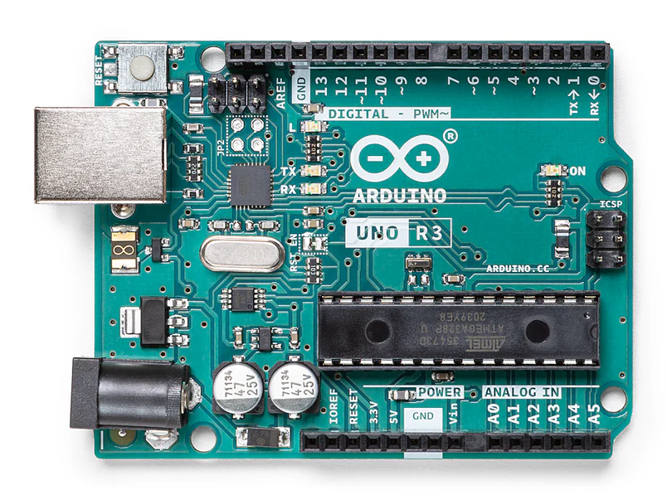
Fig 3.2 Arduino Board
- Analog Reference pin
- Digital Ground
- Digital Pins 2-13
- Digital Pins 0-1/Serial In/Out - TX/RX
- Reset Button - S1
- In-circuit Serial Programmer
- ICSP pin
- Analog In Pins 0-5
- Power and Ground Pins
- External Power Supply In (9-12VDC) - X1
- Toggles External Power and USB Power- SV1
- USB (universal serial bus)
- Crystal Oscillator
The microcontroller used on the Arduino board is essentially used for controlling all major operations. The microcontroller is used to coordinate the input taken and execute the code written in a high-level language. This code is then implemented and relevant output is generated. The choice of microcontroller varies on the requirements of the project.
The microcontroller used in the Arduino shown above is ATmega328P manufactured by ATMEL Company and it is the most common choice. Here are some features of this microcontroller.
- ATmega328P has 14 Digital I/O Pins. Out of the 14 pins, 6 provide PWM(pulse width modulation) output.
- ATmega328P can have 6 (DIP) or 8 (SMD) Analog Input Pins.
- The DC Current which is supplied to each I/O Pin is around 40 mA.
- ATmega328P has a flash memory of 32 KB.
- ATmega328P has a SRAM (Static Random-Access Memory) of 2 KB.
- ATmega328P has EEPROM (Electrically Erasable Programmable Read-Only Memory) of 1 KB.

Communication Interface
To function optimally, the Arduino needs to communicate with external devices like computers, sensors, and LEDs. By adding a communication interface, we can ensure that Arduino can receive and transfer data to external devices and therefore generate the required output. Let's understand the components that make up the Communication Interface of Arduino.
- Serial Communication (UART): The UART is a protocol used by Arduino for serial communication with other devices. UART stands for Universal Asynchronous Receiver/Transmitter and is used for bit data transfer. The built-in hardware in Arduino aids it in this communication with other sensors, actuators, Raspberry Pi’s, and other boards.
- Inter-Integrated Circuit (I2C): This is another communication protocol that comes into the picture when we want multiple connections but with minimal wiring. The way it allows communication between multiple channels is using two wires known as the SDA - Serial Data Line and SCL - Serial Clock Line. Arduino is designed with pins that help the Arduino to connect with sensors and displays without any inconvenience.
- Serial Peripheral Interface (SPI): The last serial communication protocol that is used when we need high speed for data transfer. The multiple lines used in this protocol help to connect the microcontroller to other devices. Unlike I2C, it uses different wires to coordinate different tasks like communication, clock controls, etc. This protocol is suitable for connecting Arduino with SD cards, display modules, and digital-to-analog converters (DACs).

Digital Pins
In general, digital pins are used for general purposes like taking input or generating output. The commands that are used for setting the modes of the pins are pinMode(), digitalRead(), and digitalWrite() commands.
digitalWrite() is used to turn the resistors in each pin ON or OFF which will assign a HIGH or LOW value to the pins. The maximum current that can flow in each pin is 40 mA. Here are some digital pins.
- Serial: These pins are categorized into two types namely receive (RX) and transmit
(TX) serial data. On the Arduino, the two pins are usually numbered '0' and '1' when they perform the task of communication. They are also present at pin 12 where TX flashes the LED while data is sent and RX flashes when data is being received. Sometimes, they are used with an external TTL serial module (e.g. the Mini-USB Adapter).
- External Interrupts: As the name suggests, external interrupts are used to trigger an interrupt when required. This interruption can be due to a rising or falling edge, or a change in value. Once an interrupt is called, the Arduino will come to a halt and begin working only when told. These pins are PIN '2' and '3' which are controlled using the attachInterrupt() function.
- PWM: PWM stands for pulse width modulation. The pin numbers 3, 5, 6, 9, 10, and 11 are PWM pins. The analogWrite() function is used for generating an 8-bit output. So when a large output is to be received or transmitted, the 8-bit output is generated. On certain boards like ATmega8, these pins are limited and present at 9, 10, and 11.
- SPI(serial peripheral interface): This is a synchronous serial data protocol generally used by microcontrollers. This is present at pin number 10 (SS), 11 (MOSI), 12 (MISO), and 13 (SCK) which are used by microcontrollers for communicating with different devices. The relationship can be understood as the output device acting as a slave to the master of the SPI bus.
- LED: Present at pin number 13 in some Arduino, LED is often used for testing purposes. The LED glows when the pin is HIGH, and turns off when the pin is LOW. Sometimes it is also possible to connect some external LEDS by using breadboard and jumper wires.

Analog Pins
In general, the analog pins are used for general purposes like supporting 10-bit analog-to-digital conversion (ADC) which is performed using analog the Read() function. These analog inputs can also be used as digital pins: analog input 0 as digital pin 14 through analog input 5 as digital pin 19. Analog pins are particularly helpful since they can store 0-255 bits which is not possible using digital pins. This feature is not available on every Arduino board.
• I2C(Inter-Integrated Circuit): These pins are present at numbers 4 (SDA) and 5 (SCL) and are used to perform I2C (TWI) communication. Note that we need to import the Wire library to use this protocol.

Power Pins
The power pins are used to supply the power needed for operating the Arduino. In case some external source like a jack is being used to drive the power then it can be connected to this PIN. The supply of power that each board can take varies from one design to another and it is necessary to know this range for the board that you are using. Some Arduinos don't have the VIN pin since they only accept a regulated input, one such example is lililyPad
- 5V(Power Supply): This is the voltage that is used for driving components like the microcontroller on the board. This power can only come either from VIN or a source that can provide a regulated voltage of around 5V. Any voltage less than this will not turn the Arduino on.
- GND: This is known as the Ground pin and is used to set a reference level as the ground.
This is automatically considered to be at the potential 0V.

Other Pins
- AREF: The analog reference pin is often used to set an upper limit to the voltage for analog pins. This is set using the analogReference() function.
- Reset: This pin is used to reset the state of the microcontroller by setting all values to their default values. Once all the actions have been performed or some wrong program is executed then you might want to reset the Arduino so you can use this pin for that.
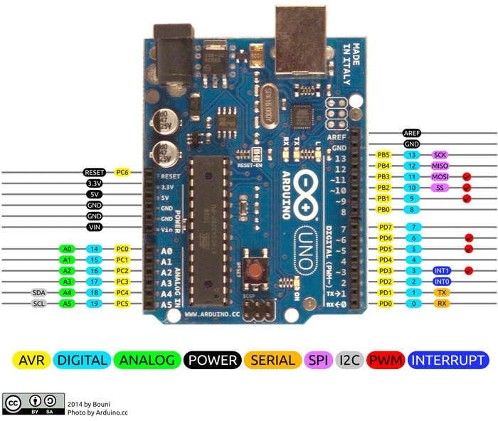

Fig 3.3 Arduino Uno Pinout
Arduino Uno is a popular microcontroller development board based on 8bit ATmega328P microcontroller. Along with ATmega328P MCU IC, it consists other components such as crystal oscillator, serial communication, voltage regulator, etc. to support the microcontroller.

Tb 3.1 Arduino Uno Pinout Configuration
Pin  Category | Pin Name | Details
Power | Vin, 3.3V, 5V, GND | Vin: Input voltage to Arduino when using an external power source.  5V: Regulated power supply used to power microcontroller and other components on the board.
3.3V: 3.3V supply generated by on-board voltage regulator. Maximum current draw is 50mA.
GND: ground pins.
Reset | Reset | Resets the microcontroller.
Analog Pins | A0 – A5 | Used to provide analog input in the range of 0-5V
Input/Output Pins | Digital Pins 0 - 13 | Can be used as input or output pins.
Serial | 0(Rx), 1(Tx) | Used to receive and transmit TTL serial data.
External Interrupts | 2, 3 | To trigger an interrupt.
PWM | 3, 5, 6, 9, 11 | Provides 8-bit PWM output.

Input Voltage Limits | 6-20V
Analog Input Pins | 6 (A0 – A5)
Digital I/O Pins | 14 (Out of which 6 provide PWM output)
DC Current on I/O Pins | 40 mA
DC Current on 3.3V Pin | 50 mA
Flash Memory | 32 KB (0.5 KB is used for Bootloader)
SRAM | 2 KB
EEPROM | 1 KB
Frequency (Clock Speed) | 16 MHz

IR SENSORS
Infrared (IR) sensors are critical components in modern technology, playing vital roles in various applications from consumer electronics to industrial automation. Understanding what an IR sensor is, how it works, its types, and its applications can provide valuable insights into how these devices contribute to various technological advancements. This comprehensive guide delves deeply into the basics, types, working principles, and uses of IR sensors.
IR sensors are electronic devices that measure and detect infrared radiation emitted by objects in their field of view. Infrared radiation is a type of electromagnetic radiation with wavelengths longer than visible light but shorter than microwaves. Every object emits some level of infrared radiation, typically as a function of its temperature. These sensors are pivotal in detecting objects and measuring temperatures without making physical contact, making them indispensable in both everyday gadgets and specialized industrial equipment.

Photodiode-based IR Sensors
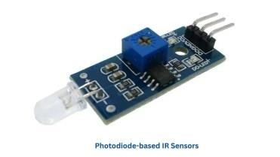
Fig 3.4 photodiode based IR sensor
These sensors use photodiodes to detect infrared radiation and convert it into an electrical signal. They are highly sensitive and used for precise applications. Photodiodes generate a current or voltage when exposed to light, and in the case of IR sensors, they are specifically tuned to respond to infrared wavelengths.
- Applications: Found in remote controls, optical communication devices, and light barriers. These sensors are integral in systems where precise detection and response to IR signals are required.
- Example: In TV remote controls, photodiode-based IR sensors receive signals to change channels or adjust the volume. The sensor detects the IR light emitted by the remote and converts it into an electrical signal that the television can interpret, allowing for seamless operation.

Working Principle of IR Sensors
The working principle of IR sensors involves the detection of infrared radiation and converting it into an electrical signal. The fundamental components of an IR sensor include:
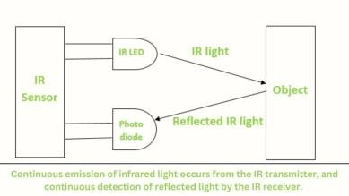
Fig 3.5 emission and detection of light by transmitter and receiver

• Emitter (IR LED)
▪ Function: Emits infrared light towards the target object. The wavelength of the IR light is typically around 850 nm to 950 nm. This emitted light illuminates the object, allowing the sensor to detect the reflected or emitted infrared light.

• Detector (Photodiode or Phototransistor)
Function: Detects the reflected or emitted infrared light from the target. The detector is sensitive to the specific wavelength of the emitted IR light, ensuring accurate detection and measurement. The detected light is then converted into an electrical signal.

• Signal Processor
o Function: Converts the detected infrared radiation into an electrical signal, which is then processed to determine the presence, distance, or temperature of the object. The signal processor may include amplifiers, filters, and analog-to-digital converters, allowing for precise analysis and interpretation of the data.
In active IR sensors, the IR LED emits infrared light, which reflects off the target object and returns to the sensor. The detector captures this reflected light and sends it to the signal processor, which calculates the distance or presence of the object based on the intensity of the reflected light. This process allows for accurate measurement and detection of objects in the sensor’s field of view.
In passive IR sensors (PIR), the sensor detects changes in infrared radiation levels in its field of view. When an object, such as a human body, enters the detection zone, the sensor registers the change in infrared radiation and triggers an appropriate response, such as turning on a light or activating an alarm. PIR sensors are highly sensitive to the infrared radiation emitted by living beings, making them ideal for security and motion detection applications.
IR Sensor Module has built-in an IR transmitter and IR receiver that sends out infrared light and looks for reflected infrared light to detect the presence of any obstacle in front of the sensor module.
It is used to find obstacles and short & medium-range communication.
There is onboard a potentiometer to adjust the detection range. There is an Obstacle Detection LED indicator on the module board.
IR sensor transmits digital data (logical 1 and 0) in the form of infrared light. When the sensor gets logical 1 means LED ON and logical 0 means LED OFF.
The sensor has a very good and stable response even in ambient light or in complete darkness.
Typically, an IR sensor will have three pins – VCC (power supply), GND (ground), and OUT (output signal).
The VCC pin is where you connect the positive terminal of your power source, while the GND pin is for connecting the negative terminal.
The OUT pin is where you receive the output signal from the sensor based on its detection of infrared radiation.
It also has a potentiometer to adjust obstacle distance.
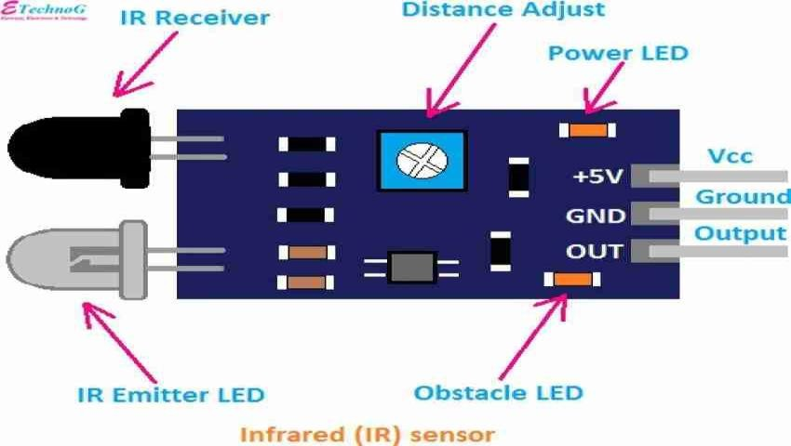
Fig 3.6 IR sensor pin out

Tb 3.2 IR sensor Pin Description
Vcc | 3.3 to 5 Vdc Supply Input
GND | Ground Input
Out | The output that goes low when an obstacle is in range
Power  LED | Illuminates when power is applied
Obstacle  LED | Illuminates when an obstacle is detected
IR Emitter | Infrared emitter LED
IR  Receiver | The infrared receiver that receives signal transmitted by Infrared emitter.

Hardware Connections
- Vcc to 5V of Arduino.
- GND to GND of Arduino.
- Out to any digital pin of Arduino.

IR Transmitter
- For transmitting IR LED of wavelength 940 nm to 950 nm are commonly used.
- This IR LED transmits the data from one end to and at another end there is an IR receiver to receive the data.

IR Receiver TSOP1738
- At the receiver end, the IR receiver receives data at 38kHz of the carrier frequency.
- Mainly, TSOP Receiver is use to receive data which support various transmitted code.
The data rate of TSOP1738 is up to 2400 bps

SERVO MOTOR
A servo motor is a special kind of electric motor designed to enable precise and accurate movement. It is commonly used in applications such as robots or machines. A servo motor is like a smart motor because it can control its position, speed, and power. This motor works with a sensor that tells it where it is, and a controller makes sure it moves the way we want it to. People use these motors a lot in big machines, especially in places like factories where we need things to move very accurately and smoothly. This article discusses servo motors, and their importance in various fields such as robotics and manufacturing, explaining how they work, how they're built, and where they are commonly used.
Servo motors are like powerful little engines with a high torque-to-inertia ratio, meaning they can generate a lot of twisting force relative to their size and weight. This makes them perfect for tasks that need quick acceleration, deceleration, and precise movements. They come in various sizes and power levels to suit different jobs and can be powered by either AC or DC voltage. What's good is that we can control their speed and force using special signals called pulse width modulation (PWM). Some servo motors have extra features like built-in controllers and communication interfaces, which makes them adaptable and easy to integrate into complex systems.
A servo motor is a rotary actuator that enables accurate control of angular position. It comprises a motor, a feedback system, and a controller. The feedback system constantly monitors the motor's actual position and adjusts it to match the desired position. The controller interprets the difference between the actual and desired positions, sending signals to the motor to correct any variations.

Fig 3.7 Servo Motor

Construction of Servo Motor
The construction of a servo motor involves many key components that are used to enable precise control of angular position. A servo motor is similar to a regular motor, but it has more additional parts to facilitate position control. These essential components include sensors, gears, and a circuit. The motor is guided by a controller, such as Arduino or STM. In industrial applications, AC servo motors utilize an encoder as a position sensor, while DC servo motors employ a potentiometer for this purpose.
A DC servo motor is assembled by combining a DC motor with various components like a gearbox, controller, and potentiometer. On the other hand, an AC servo motor uses an induction motor, complemented by gears and encoders for precise control.

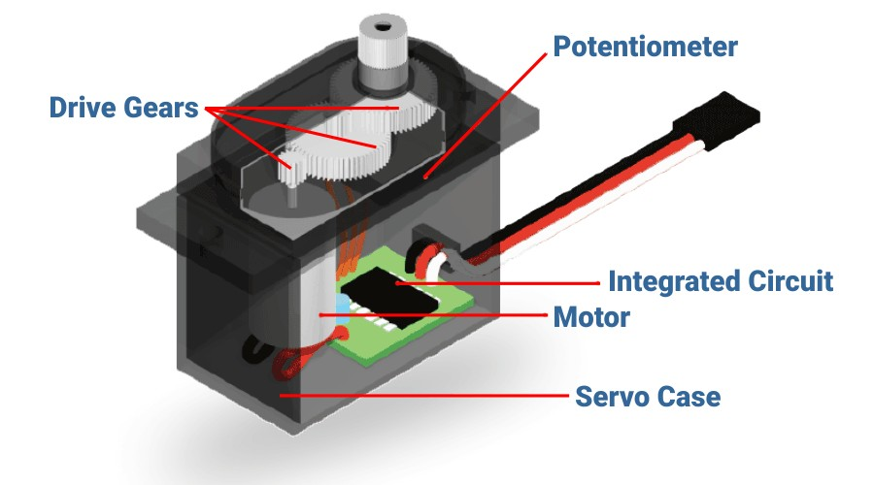
Fig 3.8 Construction of Servo Motor

Components of Servo Motor
- Rotor and Stator: The core of a servo motor consists of two main parts: the rotor (the moving part) and the stator (the stationary part). The rotor is typically connected to the output shaft, responsible for generating motion.
- Feedback Device: Incorporated within the servo motor is a feedback device, often in the form of an encoder or resolver. This device constantly monitors the actual position of the rotor and provides this information to the controller.
- Controller: The controller is the most important part of the servo motor system. It interprets the feedback from the encoder and compares it to the desired position. If there's any difference, the controller calculates the necessary adjustment.
- Control Input: The servo motor receives control input, usually in the form of electrical pulses. The controller utilizes this input to determine how much and in which direction the motor should move.
- Power Supply: The motor requires a power supply, typically in the form of direct current (DC) or alternating current (AC), depending on the motor type.
- Gear Train (optional): In some servo motors, especially those used in robotics, a gear train may be included to amplify the torque or adjust the speed of the output shaft.

Working of Servo Motor
A servo motor works in a simple way and is easy to understand. Usually, a servo motor has a system called closed-loop control. This system includes a comparator and a feedback path. It's like a setup that constantly checks and adjusts the motor to keep it in the right place. The comparator is an important part of the servo motor. It carefully checks where the motor is right now and compares it to where it's supposed to be. If there's a difference, it signals that there's an error, telling the motor to make the necessary adjustments to get to the correct position.
The block diagram below shows the components of a standard servo motor control system:
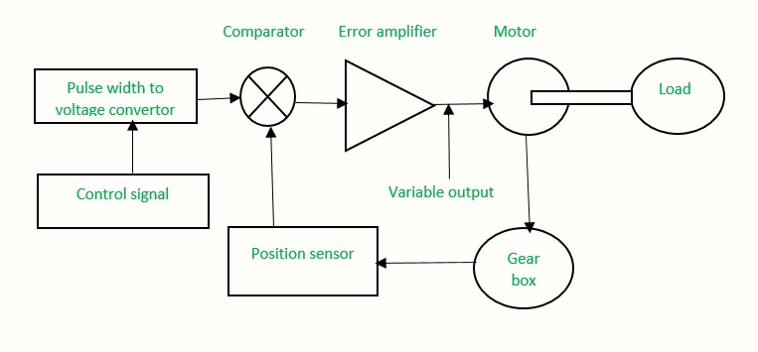
Fig 3.9 Working of Servo Motor
Servo motors are commonly controlled using a method called Pulse Width Modulation (PWM). This technique requires the transmission of an electrical signal containing pulses of different lengths to the motor. These pulses have a width that varies between 1 to 2 milliseconds, and they are sent repeatedly at a rate of 50 times per second to the servo motor. The adjustment of the pulse width serves as a means to effectively control the position of the rotating shaft in the servo motor. In simpler terms, changing the duration of these pulses guides the motor in achieving the desired position for its rotating shaft.
How To Control a Servo Motor?
Servo motors are operated by transmitting an electrical pulse, known as pulse width modulation (PWM), through a control wire. This pulse has a variable width and consists of a minimum and maximum value, along with a repetition rate. The servo motor typically has a limited range of movement, usually 180° in total, with a capability of turning 90° in either direction from its neutral position. The neutral position is the point where the servo can rotate equally in both clockwise and counter-clockwise directions.
The position of the servo motor's shaft is determined by the duration of the PWM pulse sent through the control wire. The motor anticipates receiving a pulse every 20 milliseconds (ms), and the length of the pulse dictates how far the motor will turn. For instance, a 1.5ms pulse will position the motor at 90°. Pulses shorter than 1.5ms move the motor counterclockwise toward the 0° position, while pulses longer than 1.5ms cause the servo to turn clockwise toward the 180° position.

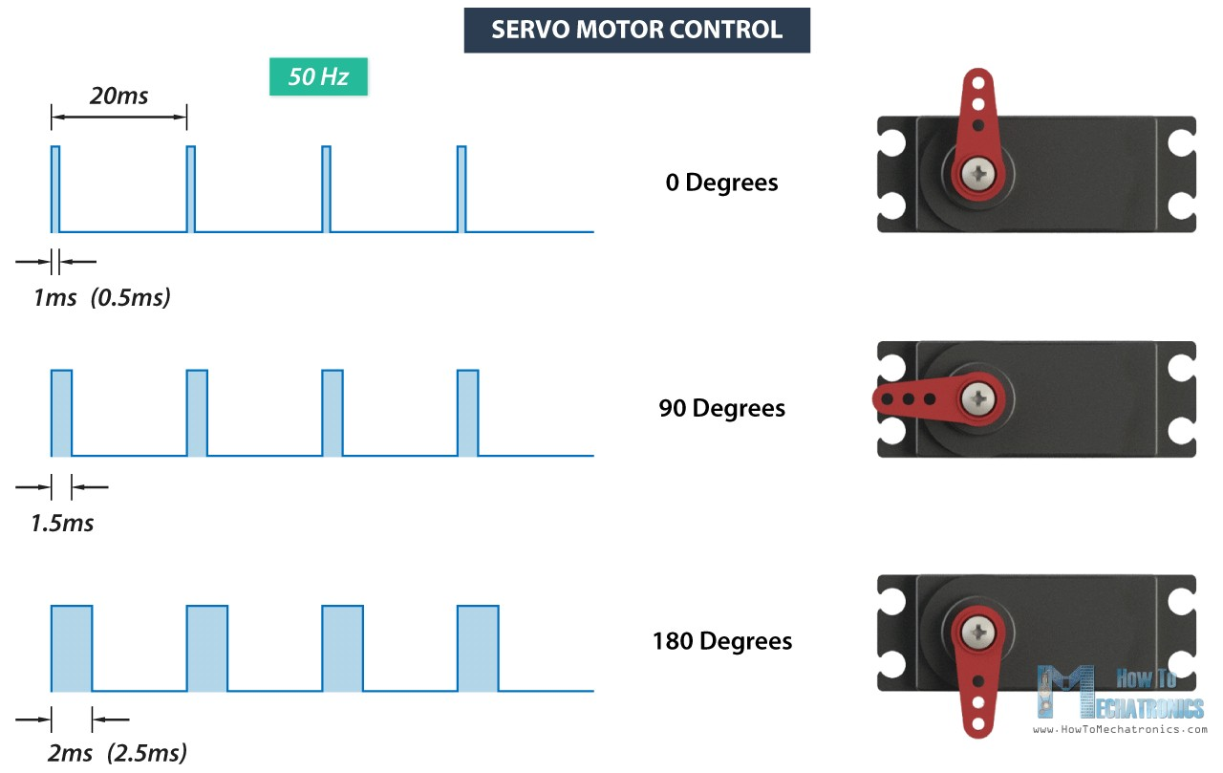
Fig 3.10 Adjusting Servo Position by Varying the Pulse Width Control
Once directed to a specific position, these servos will maintain and resist any external force attempting to displace them. The extent of force a servo can withstand is referred to as its torque rating. It's essential to note that servos don't sustain their position indefinitely; a repetition of the position pulse is required to instruct the servo to stay in the designated position.

Interfacing Servo Motors with Microcontrollers
In order to control servo motors, they need to be interfaced with microcontrollers, which act as the brain of the system. There are several methods to interface servo motors with microcontrollers. One common approach is to use pulse width modulation (PWM). PWM works by varying the width of the pulse signal to control the position of the servo motor. The microcontroller generates the PWM signal, which is then sent to the servo motor. By changing the pulse width, the microcontroller can control the angle at which the servo motor rotates. To interface a servo motor with a microcontroller, you will need to connect the servo motor to the appropriate pins of the microcontroller.
Servo Motors have three wires:
Power Ground Signal
The power and ground wires are connected to a power source, while the signal wire is connected to a PWM pin on the microcontroller. Once the hardware connections are made, you can start programming the microcontroller to control the servo motor. This involves writing code that generates the PWM signal with the desired pulse width. The microcontroller will continuously send the PWM signal to the servo motor, causing it to rotate to the desired angle. It is important to note that different servo motors may have different operating characteristics, such as the range of angles they can rotate or the speed at which they can move. Therefore, it is essential to consult the datasheet or specifications of the servo motor to ensure proper interfacing and control.
Tb 3.3 Servo Motor Wire Description
Wire Number | Wire Colour | Description
1 | Brown | Ground wire connected to the ground of system
2 | Red | Powers the motor typically +5V is used
3 | Orange | PWM signal is given in through this wire to drive the motor

LCD I2C MODULE
In the smart parking system, the LCD I2C module plays a critical role in providing real-time updates to users about the availability of parking spaces. The I2C (Inter-Integrated Circuit) communication protocol is used to interface the LCD with the Arduino microcontroller, allowing efficient control of the display while minimizing the number of pins needed for communication. Below is a detailed explanation of how the LCD I2C module fits into the system design, its functionality, and its benefits.

Overview of the LCD I2C Module
An LCD I2C module is a type of display that uses the I2C communication protocol to interface with microcontrollers. The I2C protocol allows multiple devices to communicate with a microcontroller over just two data lines (SDA - data, and SCL - clock), making it more efficient compared to standard parallel communication methods. The I2C LCD is typically used for displaying textual information, making it ideal for our system where we need to display real time parking status messages.
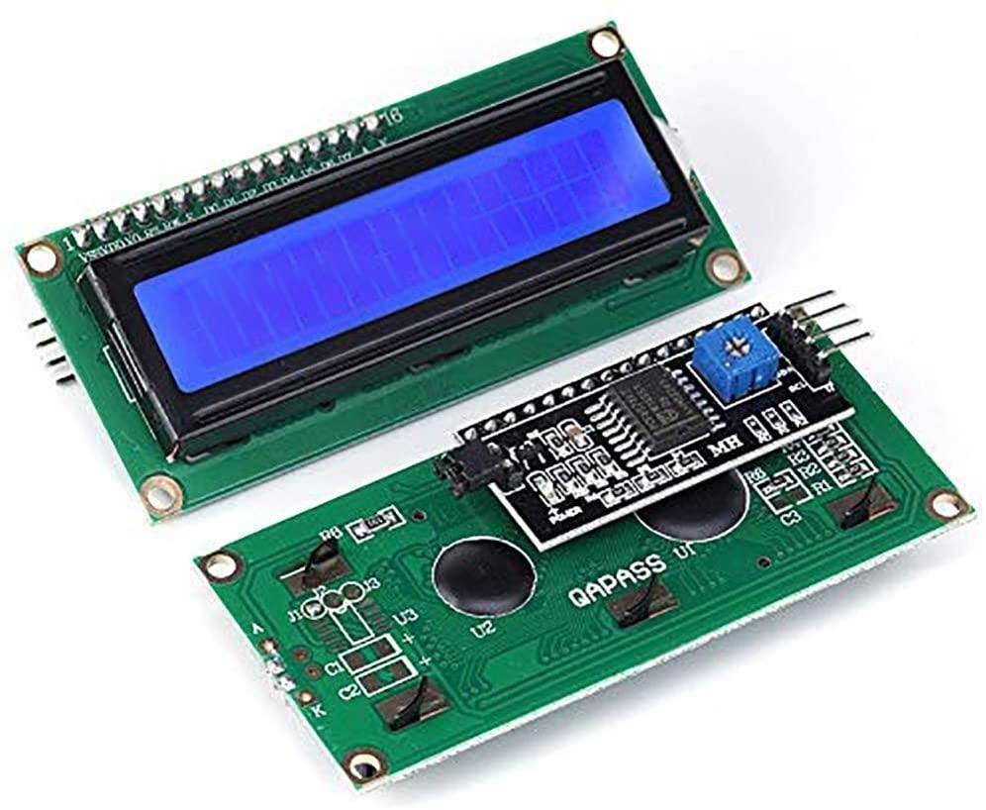
Fig 3.11 LCD with I2C interface

Features of LCD I2C Module
- 16x2 Character Display: The LCD used in this system typically has a 16x2 character grid, meaning it can display two lines of text with up to 16 characters on each line. This is suitable for displaying status messages like “Parking Available” or “No Space Available.”
- I2C Interface: The I2C interface simplifies wiring and reduces the number of microcontroller pins needed to control the display. With only two data lines (SDA and SCL), communication is efficient, and it enables the use of more pins for other components such as sensors and motors.
- Adjustable Contrast: The I2C module usually allows you to adjust the contrast of the display to make it more readable in different lighting conditions.

Role of LCD I2C Module in the Smart Parking System
The LCD I2C module is integrated into the system to display key information related to parking availability. The primary role of the LCD is to provide visual feedback to the user, making the parking process more intuitive. Here's how the LCD I2C module contributes to the system:
- Display Parking Status: The LCD continuously displays the current parking status, such as "Available Spaces: 5" or "No Spaces Available." This helps drivers quickly assess the availability of parking spots without needing to manually search through the lot.
- Real-time Updates: When a vehicle occupies or frees a parking space, the system updates the LCD in real-time to reflect the new status. This ensures that drivers have the latest information on space availability as they approach the parking lot.
- Error and Instructional Messages: The LCD can also display error messages or instructions, such as "Gate Opening" when the gate is activated or "Sensor Error" if there is an issue with the IR sensors. This enhances the user experience by providing additional context when needed.
- User Interaction Feedback: As part of the user interface, the LCD ensures drivers are informed about the system's operation. For example, it may show a message such as "Gate Open" when the entrance IR sensor detects a car, signalling that the driver can proceed.

Wiring the LCD I2C with Arduino
Wiring an I2C LCD with the Arduino is straightforward and involves only four pins:
- VCC: Connected to 5V on the Arduino.
- GND: Connected to the ground (GND) on the Arduino.
- SDA: Connected to the Arduino's data pin (A4 on most Arduino boards).
- SCL: Connected to the Arduino's clock pin (A5 on most Arduino boards).
3.2.2 SOFTWARE REQUIRED
Introduction to Arduino IDE, where IDE stands for Integrated Development Environment - An official software introduced by Arduino.cc, that is mainly used for writing, compiling and uploading the code in almost all Arduino modules/boards. Arduino IDE is open-source software and is easily available to download & install from Arduino's Official Site.

Introduction to Arduino IDE
- Arduino IDE is an open-source software, designed by Arduino.cc and mainly used for writing, compiling & uploading code to almost all Arduino Modules.
- It is an official Arduino software, making code compilation too easy that even a common person with no prior technical knowledge can get their feet wet with the learning process.
- It is available for all operating systems i.e. MAC, Windows, Linux and runs on the Java Platform that comes with inbuilt functions and commands that play a vital role in debugging, editing and compiling the code.
- A range of Arduino modules available including Arduino Uno, Arduino Mega, Arduino Leonardo, Arduino Micro and many more.
- Each of them contains a microcontroller on the board that is actually programmed and accepts the information in the form of code.
- The main code, also known as a sketch, created on the IDE platform will ultimately generate a Hex File which is then transferred and uploaded in the controller on the board.
- The IDE environment mainly contains two basic parts: Editor and Compiler where former is used for writing the required code and later is used for compiling and uploading the code into the given Arduino Module.
- This environment supports both C and C++ languages.

CHAPTER 4

SOFTWARE IMPLEMENTATION

4.1 HOW TO DOWNLOAD ARDUINO IDE
You can download the Software from Arduino main website. As I said earlier, the software is available for common operating systems like Linux, Windows, and MAX, so make sure you are downloading the correct software version that is easily compatible with your operating system.
- If you aim to download the Windows app version, make sure you have Windows 8.1 or Windows 10, as the app version is not compatible with Windows 7 or older version of this operating system.
- You can download the latest version of Arduino IDE for Windows (NonAdmin standalone version), by clicking below button:
4.2 DOWNLOAD ARDUINO IDE
The Arduino Software (IDE) makes it easy to write code and upload it to the board offline. We recommend it for users with poor or no internet connection. This software can be used with any Arduino board.
There are currently two versions of the Arduino IDE, one is the IDE 1.x.x and the other is IDE 2.x. The IDE 2.x is new major release that is faster and even more powerful to the IDE 1.x.x. In addition to a more modern editor and a more responsive interface it includes advanced features to help users with their coding and debugging.
The following steps can guide you with using the offline IDE (you can choose either IDE 1.x.x or IDE 2.x):
1. Download and install the Arduino Software IDE:
- Arduino IDE 1.x.x (Windows, Mac OS, Linux, Portable IDE for Windows and Linux, ChromeOS).
- Arduino IDE 2.x
2. Connect your Arduino board to your device.
3. Open the Arduino Software (IDE).
The Arduino Integrated Development Environment - or Arduino Software (IDE) - connects to the Arduino boards to upload programs and communicate with them. Programs written using Arduino Software (IDE) are called sketches. These sketches are written in the text editor and are saved with the file extension “.ino”.
Using the offline IDE 1.x.x
The editor contains the four main areas:
1. A Toolbar with buttons for common functions and a series of menus. The toolbar buttons allow you to verify and upload programs, create, open, and save sketches, and open the serial monitor.
2. The message area, gives feedback while saving and exporting and also displays errors.
3. The text editor for writing your code.
4. The text console displays text output by the Arduino Software (IDE), including complete error messages and other information.
The bottom right-hand corner of the window displays the configured board and serial port.
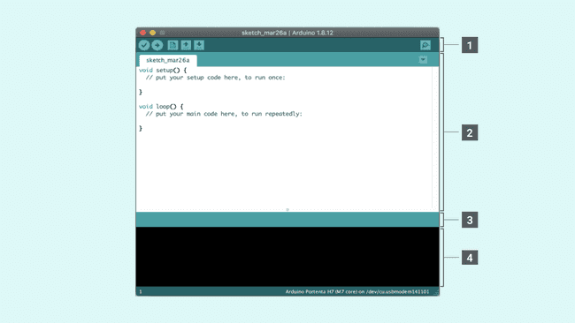Fig 4.1 The Arduino Software IDE
Now that you are all set up, let’s try to make your board blink!

5. Connect your Arduino or Genuino board to your computer.
6. Now, you need to select the right core & board. This is done by navigating to Tools > Board > Arduino AVR Boards > Board. Make sure you select the board that you are using. If you cannot find your board, you can add it from Tools > Board > Boards Manager.
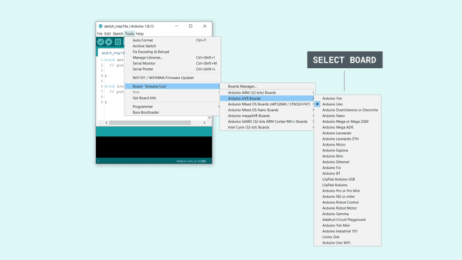Fig 4.2 Selecting a board
7. Now, let's make sure that your board is found by the computer, by selecting the port. This is simply done by navigating to Tools > Port, where you select your board from the list.
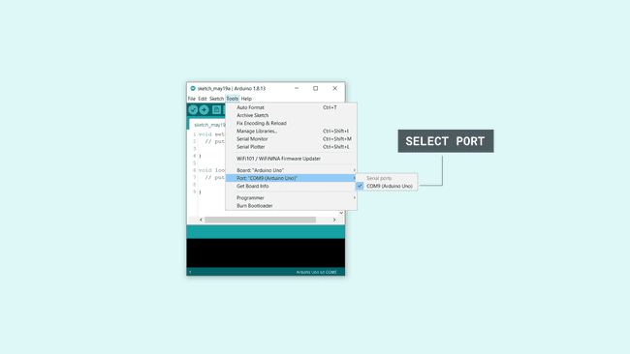Fig 4.3 Selecting the port

8. Let’s try an example: navigate to File > Examples > 01.Basics > Blink.
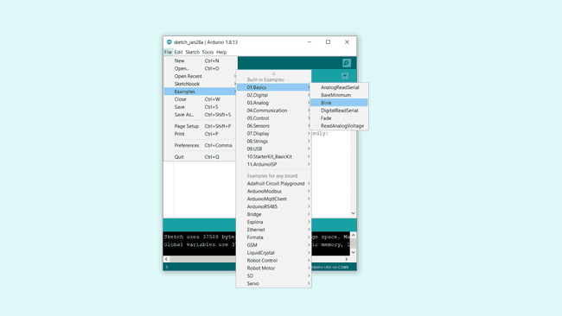Fig 4.4 Opening an example
9. To upload it to your board, simply click on the arrow in the top left corner. This process takes a few seconds, and it is important to not disconnect the board during this process. If the upload is successful, the message "Done uploading" will appear in the bottom output area.
10. Once the upload is complete, you should then see on your board the yellow LED with an L next to it start blinking. You can adjust the speed of blinking by changing the delay number in the parenthesis to 100, and upload the Blink sketch again. Now the LED should blink much faster.
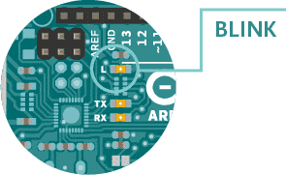
Fig 4.5 LED blink
4.3 ARDUINO CODE AND EXPLANATION:
ARDUINO CODE:
#include <Wire.h>
#include <LiquidCrystal_I2C.h>
#include <Servo.h>

// Define constants
#define GROUND_FLOOR_SLOTS 4
#define FIRST_FLOOR_SLOTS 4
#define TOTAL_SLOTS 8

int entranceSensor = 2; // Sensor at the entrance
int groundFloorSensors[GROUND_FLOOR_SLOTS] = {3, 4, 5, 6}; // Ground floor sensors
int firstFloorSensors[FIRST_FLOOR_SLOTS] = {7, 8, 9, 10}; // First floor sensors
bool slotStatus[TOTAL_SLOTS] = {false};
Servo gateServo;
LiquidCrystal_I2C lcd(0x3F, 16, 2); // LCD address and size

// Variables
int availableSlot = -1; // To store the slot number of the first available space
int currentFloor = 0; // To store the current floor of the available slot

void setup() {
// Initialize serial communication
Serial.begin(9600);

// Initialize entrance sensor
pinMode(entranceSensor, INPUT);

// Initialize slot sensors (ground and first floor)
for (int i = 0; i < GROUND_FLOOR_SLOTS; i++) {
pinMode(groundFloorSensors[i], INPUT);
}
for (int i = 0; i < FIRST_FLOOR_SLOTS; i++) {
pinMode(firstFloorSensors[i], INPUT);
}

// Initialize servo motor
gateServo.attach(11);
gateServo.write(0); // Initial position: closed

// Initialize LCD
lcd.init();
lcd.backlight();
lcd.setCursor(0, 0);
lcd.print("V PARKING YARD");
delay(2000);
lcd.clear();
}

void loop() {
// Check for vehicle at entrance
if (digitalRead(entranceSensor) == LOW) { // Vehicle detected at entrance
Serial.println("Vehicle detected at entrance.");

// Search for available slot, prioritize ground floor
availableSlot = -1; // Reset available slot
currentFloor = 0; // Start with ground floor

// Check ground floor slots first
Serial.println("Searching for available slot on ground floor...");
for (int i = 0; i < GROUND_FLOOR_SLOTS; i++) {
if (digitalRead(groundFloorSensors[i]) == HIGH) { // Slot is available
availableSlot = i;
currentFloor = 1; // Ground floor
break; // Stop searching once an available slot is found
}
}

// If no slot found on the ground floor, check first floor
if (availableSlot == -1) {
Serial.println("No available slot on ground floor. Checking first floor...");
for (int i = 0; i < FIRST_FLOOR_SLOTS; i++) {
if (digitalRead(firstFloorSensors[i]) == HIGH) { // Slot is available
availableSlot = i + GROUND_FLOOR_SLOTS; // Adjust index for first floor
currentFloor = 2; // First floor
break; // Stop searching once an available slot is found
}
}
}

// If an available slot is found, open the gate and display on LCD
if (availableSlot != -1) {
Serial.print("Available slot found at ");
Serial.print(currentFloor == 1 ? "Ground Floor" : "First Floor");
Serial.print(", slot ");
Serial.println(availableSlot + 1); // Display slot number (1-based index)

// Open the gate
gateServo.write(90); // Open gate
Serial.println("Gate opened for 5 seconds...");

lcd.clear();
// Display floor name and slot number on the same line
lcd.setCursor(0, 0);
if (currentFloor == 1) {
lcd.print("Ground Floor ");
} else {
lcd.print("First Floor ");
}
lcd.print(availableSlot + 1); // Display slot number (1-based)

delay(5000); // Keep the gate open for 5 seconds
gateServo.write(0); // Close gate
Serial.println("Gate closed.");

// Display welcome message after gate closes
lcd.clear();
lcd.setCursor(0, 0);
lcd.print("Welcome to");
lcd.setCursor(0, 1);
lcd.print("V PARKING YARD");
delay(2000); // Display welcome message for 2 seconds
} else {

// If no slot is found (parking full)
Serial.println("Parking Full! No slots available.");
lcd.clear();
lcd.setCursor(0, 0);
lcd.print("Parking Full");
delay(2000); // Display for 2 seconds before checking again
}
}

delay(500); // Adjust the delay for responsiveness
}

EXPLANATION
Arduino program simulates a parking system with features to detect vehicle entry, identify available parking slots across two floors, open/close a gate, and display parking slot availability on an LCD screen.
Key Features of the Code:
- Parking Slots and Sensors:
  - Ground floor has 4 slots, each with a sensor (groundFloorSensors array).
  - First floor has 4 slots, each with a sensor (firstFloorSensors array).
  - Sensors detect whether a parking slot is occupied or available.
- Entrance Sensor:
  - A sensor at the entrance (entrance sensor) detects incoming vehicles.
- LCD Display:
  - A 16x2 LCD (LiquidCrystal_I2C) shows the available parking slot and floor information.

- Gate Servo:
  - A servo motor (gate servo) controls the gate at the parking entrance, opening when a slot is available and closing after a delay.
- Real-Time Slot Checking:
  - The system continuously monitors sensors to detect vehicle entry and checks for available parking slots.
Walkthrough of the Code:
Setup Function (setup())
- Initialize Serial Communication:
  - Allows monitoring/debugging messages via the Serial Monitor.
- Set Up Sensors:
  - Entrance Sensor and all slot sensors are set to INPUT mode to read their states.
- Servo Motor Initialization:
  - The servo motor is attached to pin 11 and set to the closed position (0°).

- LCD Initialization:
  - The LCD is initialized and displays a welcome message for 2 seconds before clearing.
Main Logic (loop())
The system continuously monitors for vehicle entry and manages parking slots as follows:
- Detect Vehicle at Entrance:
  - If entranceSensor reads LOW, a vehicle is detected.
  - A debug message is printed to the Serial Monitor.
- Search for Available Slots:
  - Ground Floor: The system checks each slot on the ground floor by reading the groundFloorSensors array.
    - If a sensor reads HIGH, the slot is available, and the slot ID is stored in availableSlot.
    - The loop breaks when the first available slot is found.
  - First Floor: If no slots are found on the ground floor, the first floor is checked using the first Floor Sensors array.
    - Adjustments are made to the slot index for the first floor (availableSlot = i + GROUND_FLOOR_SLOTS).
- Handle Parking Availability:
  - If a Slot is Found:
    - The system displays the slot and floor information on the LCD.
    - The gate opens (90°), allowing the vehicle to enter.
    - The gate closes (0°) after a 5-second delay.
  - If No Slot is Found:
    - A "Parking Full" message is displayed on the LCD and the Serial Monitor.
- Delay Between Checks:
  - A short delay of 500ms ensures responsiveness while avoiding excessive resource usage.
Important Components:
1. Sensors:
- Entrance Sensor: Detects vehicle presence.
- Slot Sensors: Detect whether a parking slot is occupied (reads LOW) or available (reads HIGH).
2. Servo Motor:
- Acts as the parking gate, controlled with angles:
  - 0°: Closed
  - 90°: Open
3. LCD Display:
- Displays messages about the parking slot's availability and the current parking status.
4. Slot Tracking:
- Uses arrays (groundFloorSensors) and( firstFloorSensors) to track the states of parking slots.

CHAPTER 5
IMPLEMENTATION & RESULTS
The Smart Parking Management System is designed to automate the process of monitoring parking space availability in a multi-floor parking facility. This system utilizes an Arduino microcontroller, IR sensors, a servo motor, and an LCD display to provide real-time updates on parking availability, control the entrance gate, and enhance the user experience. The system is capable of detecting vehicle presence in designated parking slots and managing access to the parking area efficiently.
5.1 OBJECTIVES
- To monitor parking space availability across two floors using IR sensors.
- To control the entrance gate with a servo motor based on parking availability.
- To display real-time parking status on an LCD screen.
- To provide a user-friendly interface for drivers entering the parking facility.
5.2 COMPONENTS REQUIRED
- Microcontroller:
  - Arduino Uno: The main controller that processes inputs from sensors and controls outputs to the servo motor and LCD.
- IR Sensors:
  - 8 IR Sensors (HC-SR501): Used to detect the presence of vehicles in parking slots. Each sensor will monitor a specific parking space.
- Servo Motor:
  - SG90 Servo Motor: Controls the entrance gate, allowing it to open and close based on parking availability.
- LCD Display:
  - 16x2 LCD with I2C Module: Displays messages and parking availability status to users.
- Breadboard and Jumper Wires:
  - For circuit assembly and connections.

- Power Supply:
  - USB or battery power for the Arduino and other components.
5.2.1 HARDWARE SETUP
1. IR Sensor Configuration
- Placement:
  - The system will utilize 8 IR sensors, with 4 sensors placed on the ground floor and 4 on the first floor. Each sensor will be positioned above a designated parking slot to detect vehicle presence.
- Connections:
  - Connect the VCC pin of each IR sensor to the 5V pin on the Arduino.
  - Connect the GND pin of each IR sensor to the GND pin on the Arduino.
  - Connect the output pin of each IR sensor to a digital input pin on the Arduino (e.g., pins 3 to 10).
2. Servo Motor Setup
- Connections:
  - Connect the control wire of the servo motor to a PWM-capable pin on the Arduino (e.g., pin 11).
  - Connect the power wire (usually red) to the 5V pin on the Arduino.
  - Connect the ground wire (usually black or brown) to the GND pin on the Arduino.
3. LCD Display Connection
- Connections:
  - If using an I2C LCD, connect the SDA pin to A4 and the SCL pin to A5 on the Arduino.
  - Connect the VCC pin of the I2C module to the 5V pin on the Arduino.
  - Connect the GND pin of the I2C module to the GND pin on the Arduino.
4. Wiring Diagram
Create a wiring diagram to visualize the connections between the Arduino, IR sensors, servo motor, and LCD display. This can be done using software like Fritzing or drawn manually.
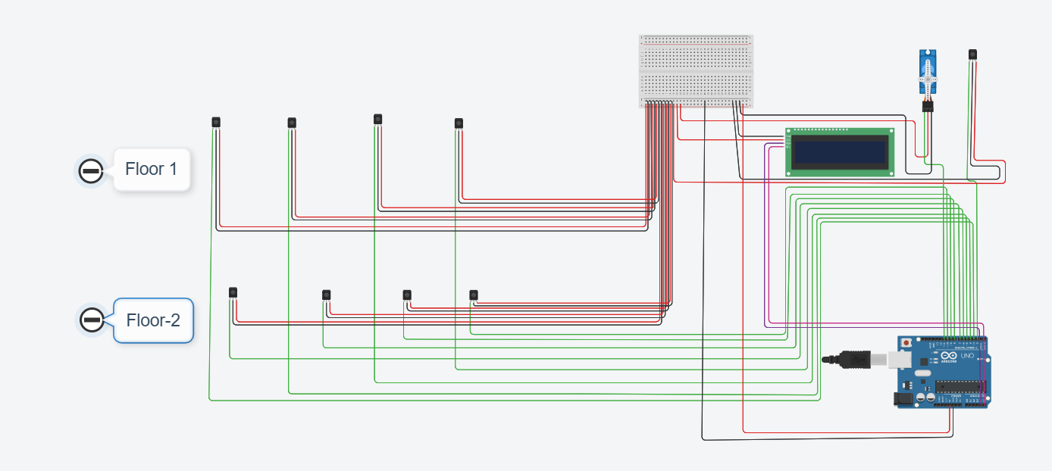
Fig 5.1 - Wiring diagram
5.3 TESTING THE SYSTEM
1. Initial Testing
- Simulate Vehicle Presence: Use objects to trigger the entrance sensor and verify that the system correctly identifies available parking slots.
- LCD Display Verification: Ensure that the LCD displays the correct status of each parking slot and updates in real-time.
- Gate Operation Testing: Confirm that the gate opens only when there is at least one available parking space and closes automatically after the designated time.
2. User Interaction Testing
- User Experience: Observe how users interact with the system. Ensure that the messages displayed on the LCD are clear and informative.

5.4 FINAL ADJUSTMENTS
1. Calibration
- Sensor Sensitivity: Fine-tune the sensitivity of the IR sensors if they are too sensitive or not sensitive enough. Adjust the placement of the sensors if necessary.
- Code Optimization: Review the code for efficiency and readability. Consider adding comments for clarity and future reference.
2. Enclosure Design
- Protective Enclosure: Design and build an enclosure for the Arduino and components to protect them from environmental factors such as dust and moisture
RESULTS
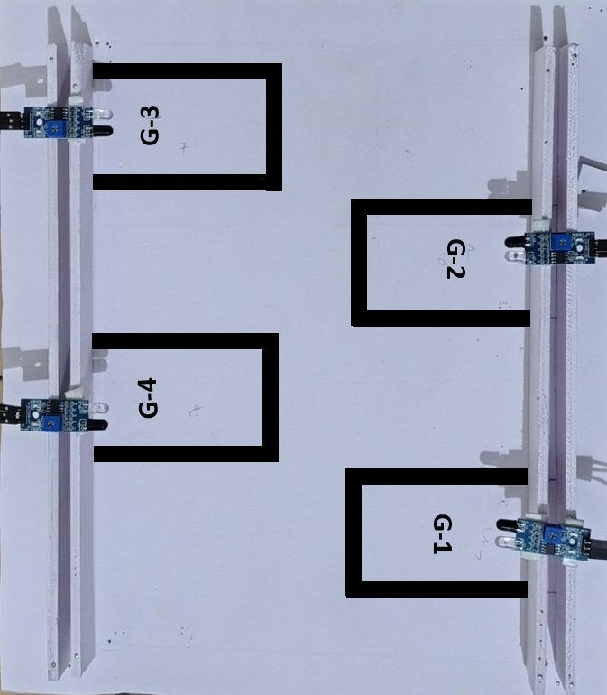
Fig 5.2 Layout of ground floor parking region
In the above figure we can see the layout of ground floor parking region. Where there will be 4 slots are mapped and named as “G-1,G-2, G-3 and G4”
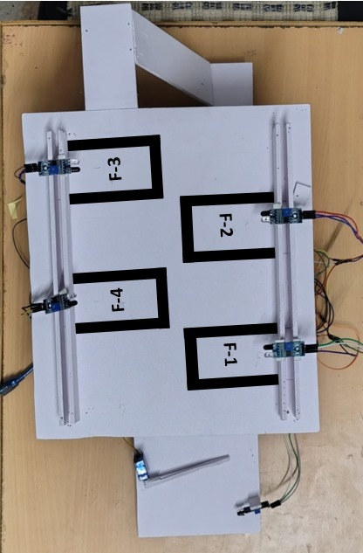
Fig 5.3 Layout of First floor parking region
In this figure we can see the layout of first floor parking region. There are another four parking slots allocated with their boundaries and they are named as “F-1, F-2, F-3 and F-4”.
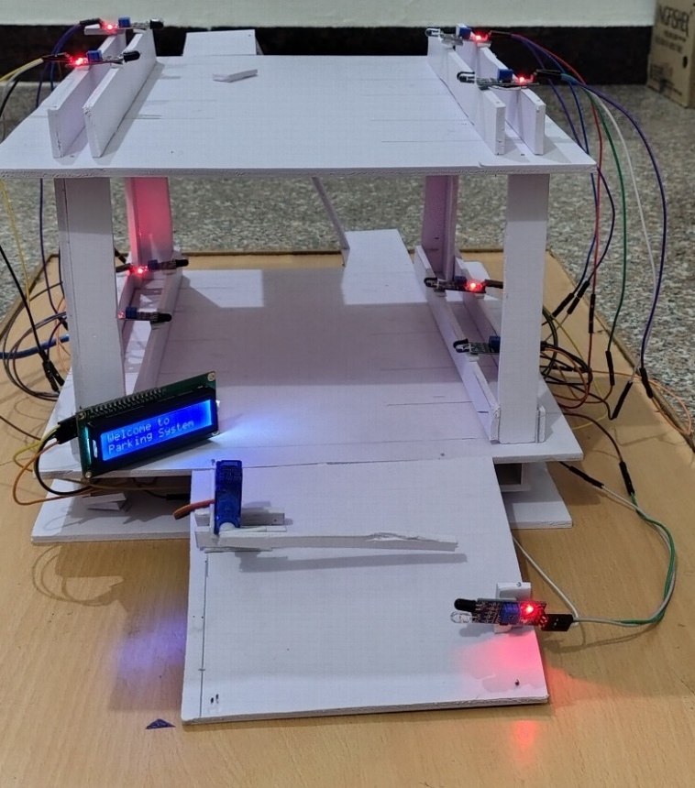

Fig 5.4 This picture shows the empty parking area when no slot is occupied

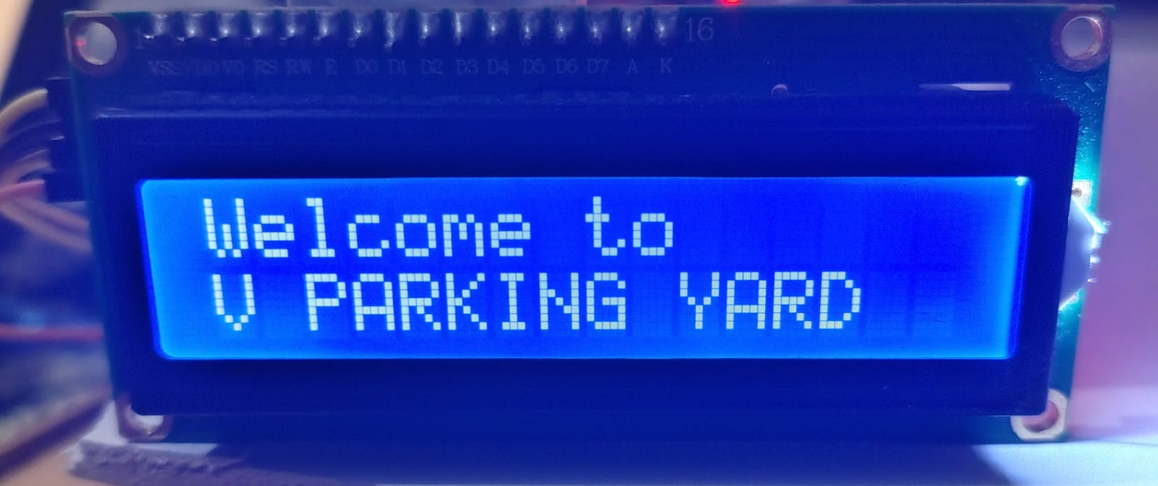

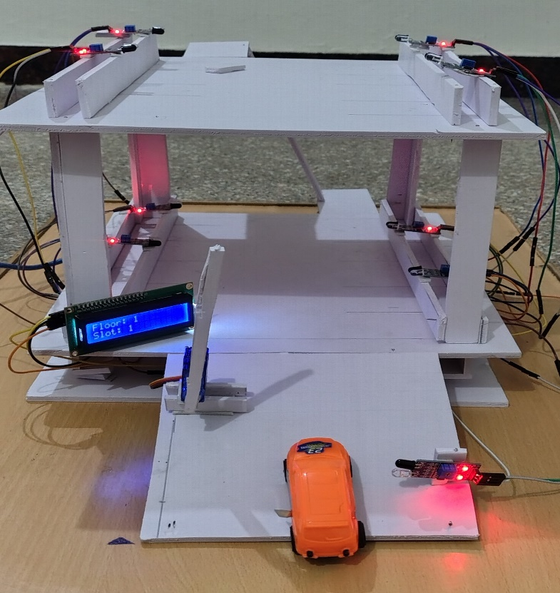

Fig 5.5 Allocation of the first slot in empty parking area
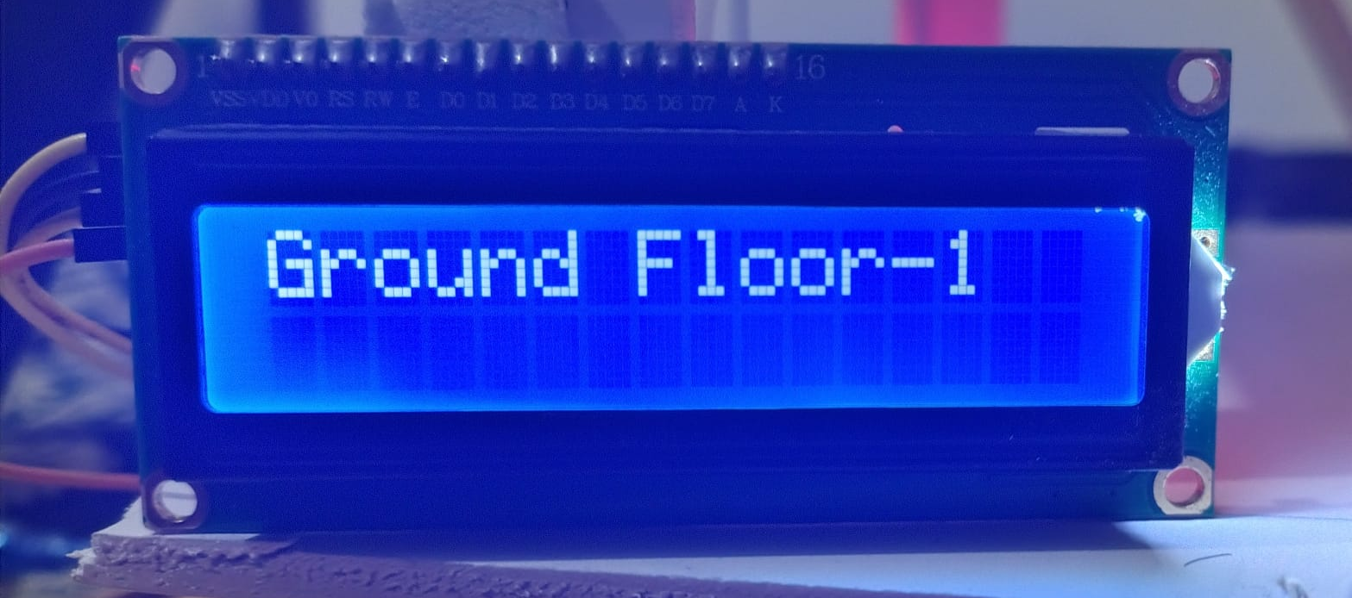
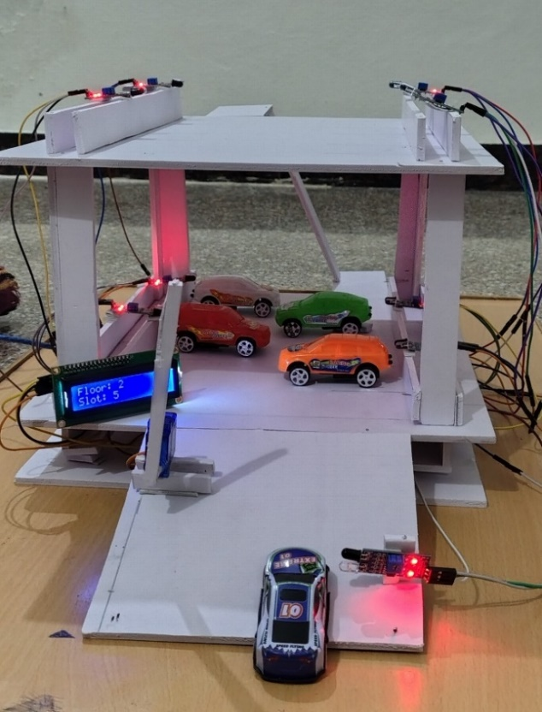
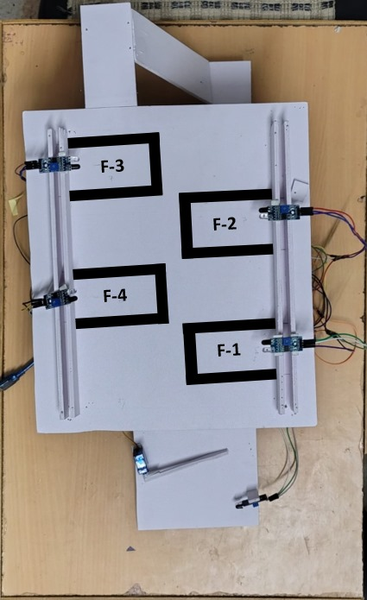
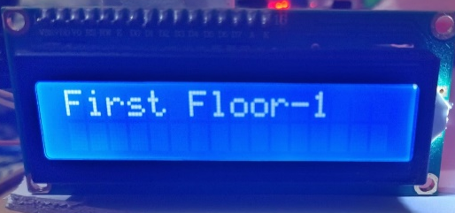
Fig 5.6 Ground floor is occupied and directing the vehicles to the upper level

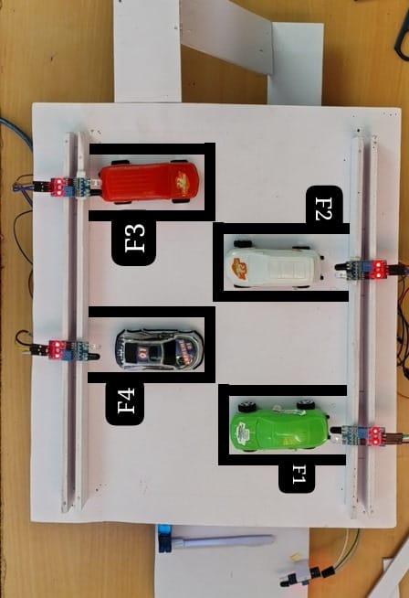
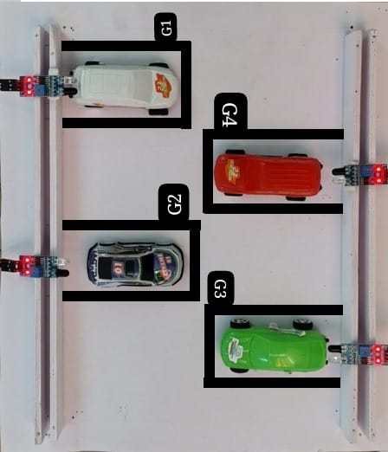
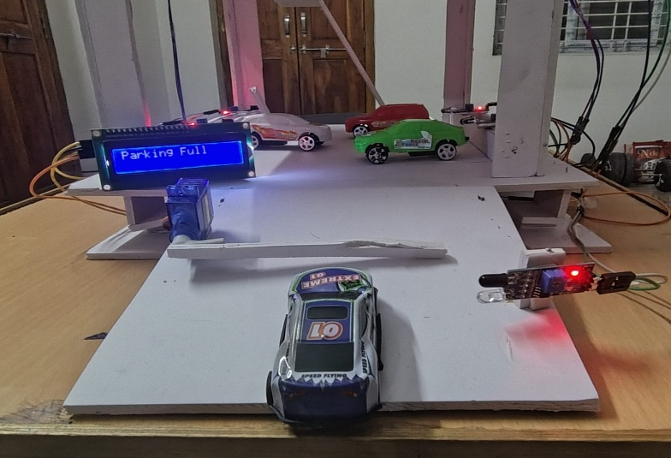
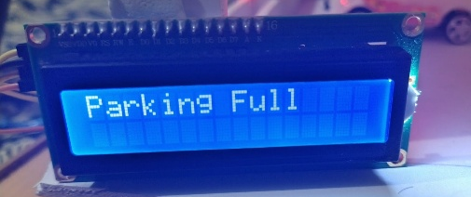

Fig 5.7 when all the slots are occupied the gate at the entrance will not open and parking full is displayed in the LCD

MODEL EXPLANATION:
Vehicle Detection:
When a vehicle approaches the entrance of the parking facility, an advanced detection system is triggered. This system uses sensors (such as ultrasonic, infrared, or camera-based technology) to identify the presence of a vehicle. Once detected, the system initiates a process to search for an available parking slot within the facility. This automated detection ensures seamless entry for vehicles while optimizing the allocation of parking spaces.
Gate Operation
To facilitate smooth entry, the system operates a motorized gate. Upon successful detection of a vehicle, the gate automatically opens for a duration of 5 seconds, providing sufficient time for the vehicle to pass through. After the allotted time, the gate closes automatically to maintain security and control access. This precise timing ensures efficiency and minimizes the risk of unauthorized entry.
Welcome Message
After the vehicle has successfully entered the premises and the gate has closed, the system displays a friendly welcome message on an LCD or digital screen. This personalized interaction enhances the user experience and provides assurance that the vehicle is being guided to an available parking slot. The welcome message can also include additional details, such as parking guidelines or the allocated slot number.
FIGURE 5.4: Initial State of Parking Area
In the scenario depicted by Figure 6.1, the parking area is entirely empty, with no slots currently occupied. When a vehicle enters the parking facility, the detection system activates and begins checking for available parking slots. Each parking slot is equipped with a sensor that continuously monitors its status. If a sensor reads HIGH, it indicates that the slot is available, and the system stores the corresponding slot ID in a variable called availableSlot. The system iterates through all the sensors, checking their readings to identify which slots are free. Once an available slot is found, the vehicle is directed to that slot for parking, ensuring efficient space utilization.
FIGURE 5.5: Slot Allocation on Ground Floor
In Figure 6.2, When a vehicle enters the parking facility, the detection system activates and begins scanning for available parking slots on the ground floor. Each parking slot is equipped with a sensor that continuously monitors its status. If a sensor reads HIGH, it indicates that the slot is available, and the system stores the corresponding slot ID in a variable called availableSlot. The system specifically checks the sensors on the ground floor first to prioritize accessibility for incoming vehicles. Once an available slot is found on the ground floor. .The system opens the gate and communicates the specific floor and slot number through an LCD screen or a similar display. This ensures that the driver is guided efficiently to the vacant slot, reducing the time spent searching for parking.
FIGURE 5.6: Slot Allocation on the First Floor
Figure 6.3 illustrates a situation where no slots are available on the ground floor. In this case, the system checks for availability on the first floor.. If a sensor reads HIGH, it indicates that the slot is available, and the system stores the corresponding slot ID in a variable called availableSlot. Once an available slot is found on the first floor, the vehicle is guided to that slot for parking, facilitating an efficient and organized parking process. If a slot is found on the first floor, the same procedure is followed: the gate opens, and the system displays the floor and slot number to guide the driver to the vacant space. This multi-floor allocation ensures maximum utilization of parking resources.
FIGURE 5.7: Parking Full Scenario
Figure 6.4 represents the situation, When a vehicle approaches the parking facility and the detection system is activated, it begins scanning for available parking slots on both the ground and first floors. Each parking slot is equipped with sensors that continuously monitor their status. As the system checks the sensors, it finds that all readings are LOW, indicating that every slot on both floors is occupied.
In this scenario, the system recognizes that there are no available slots and triggers an alert to inform the driver that the parking facility is full, the system displays a “Parking Full” message on the LCD or digital screen to inform the driver... This ensures that the driver is informed and can make an informed decision, preventing frustration and optimizing the overall parking experience
Summary:
Overall, the code effectively manages a simple parking system, allowing vehicles to enter and providing clear feedback to users through the LCD. The system is designed to be responsive, checking for vehicle presence and slot availability continuously. The use of a servo motor for gate control and sensors for detecting vehicle presence makes it a practical solution for managing parking spaces.

CHAPTER 6
CONCLUSION

The Automated Parking System project has successfully demonstrated the potential of intelligent systems in addressing urban parking challenges. This system, integrating hardware and software components such as IR sensors, Arduino microcontrollers, stepper motors, and LCD displays, provides an efficient, automated solution to parking management. The primary goal of optimizing parking space allocation and automating the entrance/exit gate based on real-time availability has been achieved.
6 1 SUMMARY OF FINDINGS AND ACHIEVEMENTS:
- Automated Parking Detection: The system accurately detects available parking spaces in real-time using IR sensors, improving the efficiency of space usage and reducing the time spent searching for a spot.
- Gate Control Mechanism: The servo motor successfully opens and closes the parking entrance gate based on the presence of vehicles, making the entry process seamless for drivers.
- Real-Time Feedback: The LCD display provides users with clear and immediate information on the availability of parking spaces, ensuring a smooth user experience.
- System Integration: The communication between hardware components, including the sensors, motor, and display, was smooth, resulting in a reliable and responsive system. The code executed on the Arduino microcontroller handled the logic of space checking, gate control, and user display without significant delays or errors.
This project successfully highlights how automation can enhance urban infrastructure. It reduces human intervention, streamlines parking operations, and improves the overall efficiency of parking systems. Furthermore, the system has demonstrated its potential for scalability, as it can be expanded to larger parking areas or integrated into multi-floor parking facilities with more sensors.

6.2 REFLECTION ON THE PROJECT’S IMPACT AND EFFECTIVENESS:
The impact of this project lies in its contribution to urban mobility solutions. By providing an automated and user-friendly parking system, it alleviates common problems like congestion in parking lots, unnecessary fuel consumption, and increased pollution. For users, the simplicity of the system—automatic detection, seamless gate control, and easy-to-read parking space availability—makes it a highly effective solution for everyday parking needs.
For cities, such intelligent systems can reduce the pressure on existing parking infrastructure. With proper implementation, this system can be adapted to help manage larger parking facilities, integrating with future smart city solutions, including mobile applications or real-time data-sharing platforms for parking availability.
In conclusion, the Automated Parking System represents a practical and efficient approach to modern parking management. The successful implementation of this project provides a foundation for future work in enhancing parking systems and integrating them with other smart city technologies.

CHAPTER 7
FUTURE SCOPE
- Interactive Digital Display:
The system can be upgraded to feature a large interactive digital screen at the parking facility's entrance. This screen would visually represent the parking layout, using color codes to indicate slot occupancy—green for available and red for occupied. Real-time updates would ensure users have the most current information before entering. This enhancement would reduce congestion at the entrance and improve the overall user experience. Additionally, the interactive display could provide directions to available slots, further streamlining the parking process.
- QR Code Integration:
Implementing a QR code system at the entrance would allow users to scan the code with their smartphones for instant access to parking information. Upon scanning, users would be directed to a mobile-friendly web application displaying the parking layout and highlighting unoccupied slots. This feature would enable users to select their preferred parking space and receive navigation instructions to guide them there. By simplifying the process, this integration would enhance user satisfaction and reduce the time spent searching for parking. It would also encourage the use of mobile technology for a more connected experience.
- Mobile Application Development:
A dedicated mobile application could be developed to enhance user interaction with the smart parking system. The app would provide real-time updates on parking availability and allow users to reserve spots in advance. Users could also receive notifications when their selected slot becomes available, ensuring a seamless experience. Additionally, the app could facilitate payment processing for parking fees, making transactions more convenient. This mobile solution would cater to the growing trend of smartphone usage, further improving user engagement.
- Integration with Navigation Systems:
Future iterations of the system could integrate with popular navigation applications like Google Maps and Waze. This integration would provide users with directions to the parking facility, along with real-time updates on available slots. By offering this feature, users could plan their trips more effectively, reducing the time spent searching for parking. The system could also suggest alternative routes based on current traffic conditions, enhancing the overall travel experience. This seamless integration would position the smart parking system as a valuable tool for urban mobility.
- Data Analytics and Reporting:
Enhancing the system with data analytics capabilities would allow for the monitoring of parking patterns and user behavior. By collecting and analyzing data on peak usage times and space utilization, parking management could make informed decisions for operational improvements. This data could be used to generate reports that help identify trends and inform future expansions or modifications of the parking facility. Additionally, insights gained from user behavior could lead to tailored marketing strategies and promotions. Overall, data analytics would contribute to a more efficient and responsive parking management system.
- Automated Payment Systems:
Implementing an automated payment system would streamline the payment process for users. This system could support various payment methods, including mobile apps and contactless payments, making transactions quick and convenient. Users could receive digital receipts and notifications regarding their parking sessions, enhancing transparency. Additionally, the system could offer features like hourly rates, daily maximums, and discounts for frequent users. By simplifying payments, the system would improve user satisfaction and encourage repeat usage.
- Smart Reservation System:
A smart reservation system could be introduced, allowing users to book parking spaces in advance. This feature would be particularly beneficial during peak times or special events, ensuring users have guaranteed parking upon arrival. Users could select their preferred slots and receive confirmation through the mobile app. The reservation system would also help optimize space utilization by reducing the likelihood of no-shows. Overall, this feature would enhance the convenience and reliability of the parking experience.
- Sustainability Features:
Future developments could include the integration of electric vehicle (EV) charging stations within the parking facility. The system could monitor the availability of these charging stations and provide users with real-time information on their status. Additionally, incorporating solar panels to power the system could enhance sustainability efforts and reduce operational costs. This commitment to sustainability would appeal to environmentally conscious users and promote the use of electric vehicles. Overall, these features would position the parking facility as a forward-thinking, eco-friendly solution.
- Enhanced Security Features:
Implementing security measures such as surveillance cameras and license plate recognition technology would improve safety within the parking facility. These features would help monitor vehicle activity and deter theft or vandalism, providing peace of mind for users. The system could send alerts to management in case of suspicious activity, allowing for prompt responses. Additionally, integrating security features with the mobile app could enable users to report incidents directly. Overall, enhanced security would foster a safer parking environment and build user trust.
- User Feedback Mechanism:
Establishing a user feedback mechanism within the mobile application or digital display would allow users to report issues and suggest improvements. This feature would enable users to provide ratings for their parking experience, offering valuable insights for continuous improvement. Management could analyze feedback to identify common concerns and prioritize enhancements. Additionally, engaging users in this way would foster a sense of community and ownership over the parking facility over feedback.

REFERENCES

- Dalal, Y. M., Kumar Raja, D. R., & Ashwin Kumar, U. (2023). Eco Park: A low-cost and sustainable approach for smart parking systems. In 2023 World Conference on Communication & Computing (WCONF). IEEE.
- GokulKrishna, S., Harsheetha, J., Akshaya, S., & Jeyabharathi, D. (2021). An IoT based smart outdoor parking system. In 2021 7th International Conference on Advanced Computing and Communication Systems (ICACCS). IEEE.
- Askarbek, K., & Bahrami, M. R. (2023). Smart parking systems: A review on user interface features and real-world examples. In 2023 International Ural Conference on Electrical Power Engineering (UralCon). IEEE.
- Hainalkar, G. N., & Vanjale, M. S. (2017). Smart parking system with pre & post reservation, billing and traffic app. In 2017 International Conference on Intelligent Computing and Control Systems (ICICCS). IEEE.
- Campo, G., Cipria, F., Russo, M., Santoro, C., & Santoro, F. F. (2024). ChirpPark: A smart and sustainable parking system protocol for smart cities and multi-agent vehicles. In 2024 IEEE Smart Cities Futures Summit (SCFC). IEEE.
- Arunkumar, S., Vanitha Sheba, M., Usha Naidu, S., Balaji Vijayan, V., Arun, S., & Thiagarajan, R. (2024). Seamless Wi-Fi integration enhancing the experimental model of smart car parking systems with IoT and modulated sensors. In 2024 2nd International Conference on Sustainable Computing and Smart Systems (ICSCSS). IEEE.
- Jenila, C., & Harshan, K. (2024). IoT-based smart parking system: Hardware-centric approach for addressing urban parking challenges. In 2024 2nd International Conference on Networking, Embedded and Wireless Systems (ICNEWS). IEEE.
- Bandung, Y., Aldiansyah, M. F. N., Putra, M. R. D., & Syiraaj, M. I. I. (2023). Design and implementation of IoT-based smart parking system in campus area. In 2023 10th International Conference on ICT for Smart Society (ICISS). IEEE.
- Pankiv, Y., Kunanets, N., Artemenko, O., Veretennikova, N., & Nebesnyi, R. (2021). Project of an intelligent recommender system for parking vehicles in smart cities. In 2021 IEEE 16th International Conference on Computer Sciences and Information Technologies (CSIT). IEEE.
- Tamam, I., Wang, S., & Djahel, S. (2020). An IoT-based eco-parking system for smart cities. In 2020 IEEE International Smart Cities Conference (ISC2). IEEE.
- Melnyk, P., Djahel, S., & Nait-Abdesselam, F. (2019). Towards a smart parking management system for smart cities. In 2019 IEEE International Smart Cities Conference (ISC2). IEEE.
- Anand, A., Kumar, A., Rao, A. N. M., Ankesh, A., & Raj, A. (2020). Smart parking system (S-Park) – A novel application to provide real-time parking solution. In 2020 Third International Conference on Multimedia Processing, Communication & Information Technology (MPCIT). IEEE.
- Yazıcı, A. B., & Ünverdi, N. Ö. (2024). LoRa technology overview and smart parking system design. In 2024 32nd Signal Processing and Communications Applications Conference (SIU). IEEE.
- Revathi, G., & Dhulipala, V. R. S. (2012). Smart parking systems and sensors: A survey. In 2012 International Conference on Computing, Communication and Applications. IEEE.
- Anwar, A., Ijaz-ul-Haq, Nagham, S., & Saadati, P. (2021). Smart parking: Novel framework of secure smart parking solution using 5G technology. In 2021 IEEE International Smart Cities Conference (ISC2). IEEE.
- Rana, S., & Painuly, S. (2023). Automated parking systems: A review. In 2023 International Conference on Computing, Communication, and Intelligent Systems (ICCCIS). IEEE.
- Hassoune, K., Dachry, W., Moutaouakkil, F., & Medromi, H. (2016). Smart parking systems: A survey. In 2016 11th International Conference on Intelligent Systems: Theories and Applications (SITA). IEEE.
- Agarwal, S., Gupta, S., Agarwal, P., Sharma, G., & Tripathi, V. (2023). PARKIT: An Android-based real-time smart parking system using IoT. In 2023 10th International Conference on Computing for Sustainable Global Development (INDIACom). IEEE.
- Kazi, S., Nuzhat, S., Ansari, N., & Qureshi, R. (2018). Smart parking system to reduce traffic congestion. In 2018 International Conference on Smart City and Emerging Technology (ICSCET). IEEE.
- Šilar, J., Růžička, J., Bělinovà, Z., Langr, M., & Hlubučková, K. (2018). Smart parking in the smart city application. In 2018 Smart City Symposium Prague (SCSP). IEEE.
- Ampuni, A., Fonataba, S., Fitrianto, A., & Wang, G. (2019). Smart parking system with automatic cashier machine utilize the IoT technology. In 2019 International Conference on ICT for Smart Society (ICISS). IEEE.
- Michel-Torres, D. A., Luque-Vega, L. F., Lopez-Neri, E., Carlos-Mancilla, M. A., & Gonzalez-Jiménez, L. E. (2019). IoT based smart vehicle presence sensor SPIN-V for smart parking system. In 2019 14th Annual Conference System of Systems Engineering (SoSE). IEEE.
- Agrawal, P., Mundada, P., Ikhar, J., Rakesh, N., Kaur, G., & Pinjarkar, L. (2024). Maximizing urban space: A survey of smart parking techniques and innovations. In 2024 First International Conference on Technological Innovations and Advance Computing (TIACOMP). IEEE.
- Vakula, D., & Krishna Kolli, Y. (2017). Low cost smart parking system for smart cities. In 2017 International Conference on Intelligent Sustainable Systems (ICISS). IEEE.
- Ajchariyavanich, C., Limpisthira, T., Chanjarasvichai, N., Jareonwatanan, T., Phongphanpanya, W., Wareechuensuk, S., Srichareonkul, S., Tachatanitanont, S., Ratanamahatana, C., Prompoon, N., & Pipattanasomporn, M. (2019). Park King: An IoT-based smart parking system. In 2019 IEEE International Smart Cities Conference (ISC2). IEEE
- Wong, J. W., Ramiah, S., & Kamsin, I. F. (2022). ParkSmart: Smart parking payment system. In 2022 IEEE 2nd Mysore Sub Section International Conference (MysuruCon). IEEE.
- Fraifer, M., & Fernström, M. (2016). Smart car parking system prototype utilizing CCTV nodes: A proof of concept prototype of a novel approach towards IoT-concept based smart parking. In 2016 IEEE 3rd World Forum on Internet of Things (WF-IoT). IEEE.
- Waheed, A., & Krishna, P. V. (2020). Comparing biometric and blockchain security mechanisms in smart parking system. In 2020 International Conference on Inventive Computation Technologies (ICICT). IEEE.
- Alsafery, W., Alturki, B., Reiff-Marganiec, S., & Jambi, K. (2018). Smart car parking system solution for the Internet of Things in smart cities. In 2018 1st International Conference on Computer Applications & Information Security (ICCAIS). IEEE

